

**PRATHMESH PATIL**

**A71004819033**

**BCA SEM4**

AMITY UNIVERSITY MAHARASHTRA

Amity Institute of Information Technology

This is to certify that Mr. Prathmesh Patil is a Bonfire student of Amity Institute of Information Technology, at Amity University Maharashtra and he has done the project work titled “Java Programing” at Amity University Mumbai as prescribed by AIIT, AUM in partial fulfilment of the requirement of BCA Program for the academic year 2021-22.

Teacher’s signature :-

**JAVA INDEX**

|  |  |  |
| --- | --- | --- |
| Index No | Experiments | Date |
| 1 | Write a Java Program to print Hello and check if the number is even or odd. | 11thJanuary2021 |
| 2 | Write a Java Program to accept String from a user and print it. Also print the first command line argument entered. | 11/1/21 |
| 3 | Write a Java Program to add two numbers entered as string by the user and sum of numbers passed by the command line argument. | 11/1/21 |
| 4 | Write a Java Program to calculate Area of a Rectangle and Area of a Circle using Interface. | 12/1/21 |
| 5 | Write a Java Program to perform addition using a default and a parameterized constructor. | 17/1/21 |
| 6 | Write a Java Program to perform inheritance and multiple inheritance (Interface). | 18/1/21 |
| 7 | Write a program in java for creating file using file handling. | 24/1/21 |
| 8 | Write a program in java for writing in a file. | 3/2/21 |
| 9 | Write a program in a java for reading a file. | 4/2/21 |
| 10 | Write a program in java for deleting a file. | 5/2/21 |
| 11 | Write a Java program to display number of mouse clicked | 11/2/21 |
| 12 | Write a Java Program to implement GUI and display the following keys  • Perform addition and factorial.  • Show output of factorial on a text pane  • Show output of addition on a text pane and a Dialogue Message. | 13/2/21 |
| 13 | Write a java program to Enter Gender and display it in a Dialogue Message | 14/2/21 |
| 14 | Write a java program to Display the x and y axis of the mouse | 16/2/21 |
| 15 | Write a java program to Show msg when mouse mouse move inside the panel | 21/2/21 |
| 16 | Write a program to display a Rectangle and Circle on mouseclick. | 23/2/21 |
| 17 | Write a Java Program to implement GUI and Select hobbies using Jcheckbox and display it. | 2/3/21 |
| 18 | Write a java program to Create 3 sliders with colours set in each one of them and display the colour changes inside a panel. | 3/3/21 |
| 19 | Create a random probability of a coin toss and display the outcome | 4/3/21 |
| 20 | Write a java program to add two string using gui | 5/3/21 |
| 21 | Write java program to create combobox | 12/3/21 |
| 22 | Write java program to create menu | 14/3/21 |
| 23 | Write java program to create radio button | 18/3/21 |
| 24 | Write java program to run threads | 25/3/21 |
| 25 | Write java program to demo date from gui | 27/3/21 |
| 26 | Write java program to display server and client |  |
| 27 | Write java program to create vector gui |  |
| 28 | Write java program to create server and client connection by sending message |  |
| 29 | Write java program to access database connection and view table | 6/4/21 |

Q1. Write a Java Program to print Hello and check if the number is even or odd.

Code:-

**import** java.util.Scanner;

**public** **class** Exp1 {

**public** **static** **void** main(String[] args) {

System.***out***.println("Hello world");

**int** num;

System.***out***.println("Enter an Integer number:");

Scanner input = **new** Scanner(System.***in***);

num = input.nextInt();

**if** ( num % 2 == 0 )

System.***out***.println("Entered number is even");

**else**

System.***out***.println("Entered number is odd");

}

}

Output:-

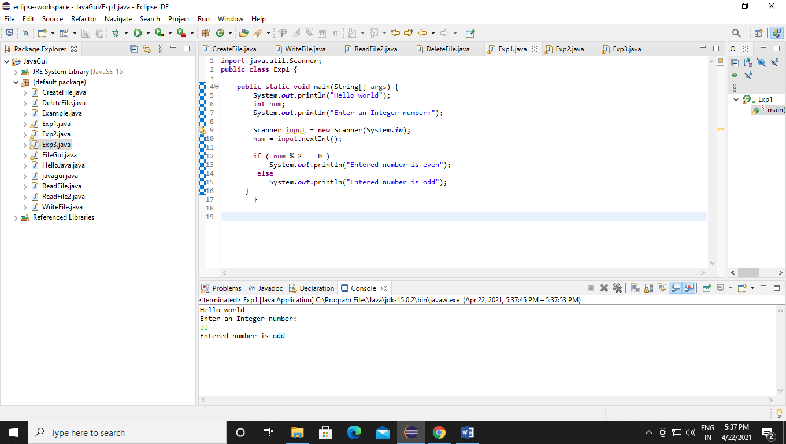

Q2. Write a Java Program to accept String from a user and print it. Also print the first command line argument entered.

Code:-

**import** java.util.Scanner;

**public** **class** Exp2 {

**public** **static** **void** main(String[] args) {

Scanner sc= **new** Scanner(System.***in***);

System.***out***.println("Enter a string: ");

String str= sc.nextLine();

System.***out***.println("You have entered: "+str);

System.***out***.println("Your first argument is: "+args[0]);

}

}

Output:-

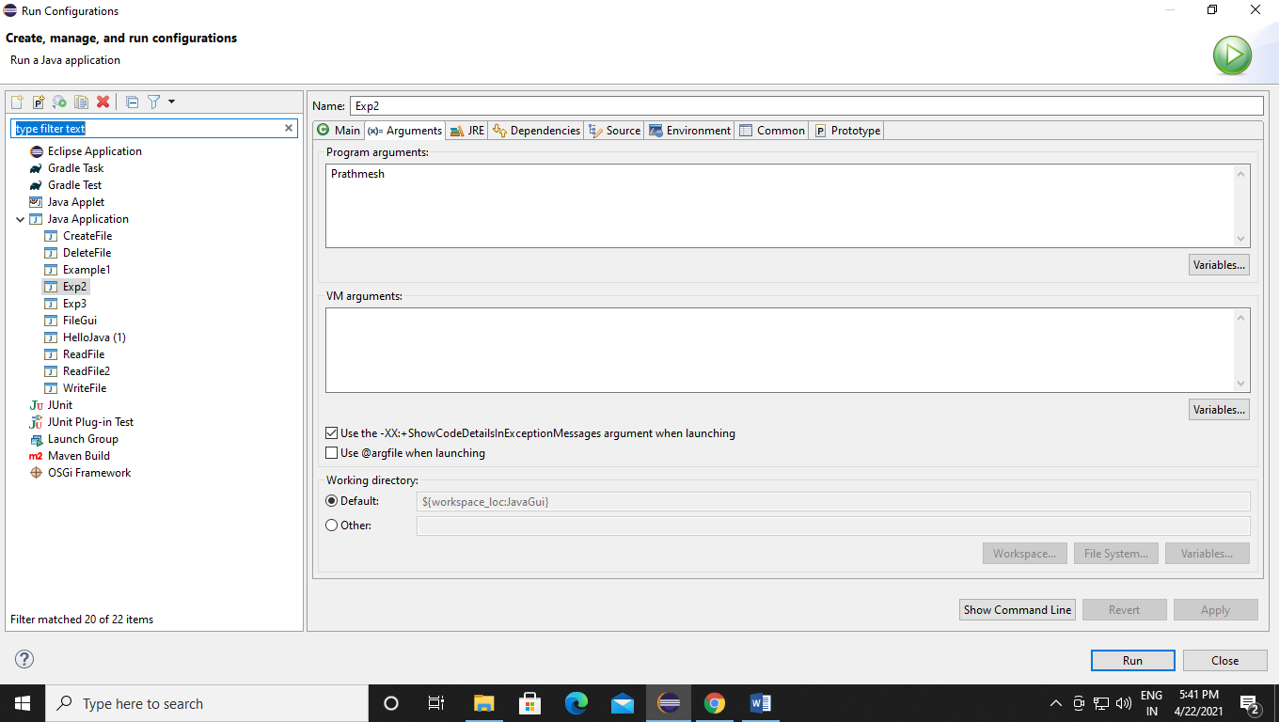

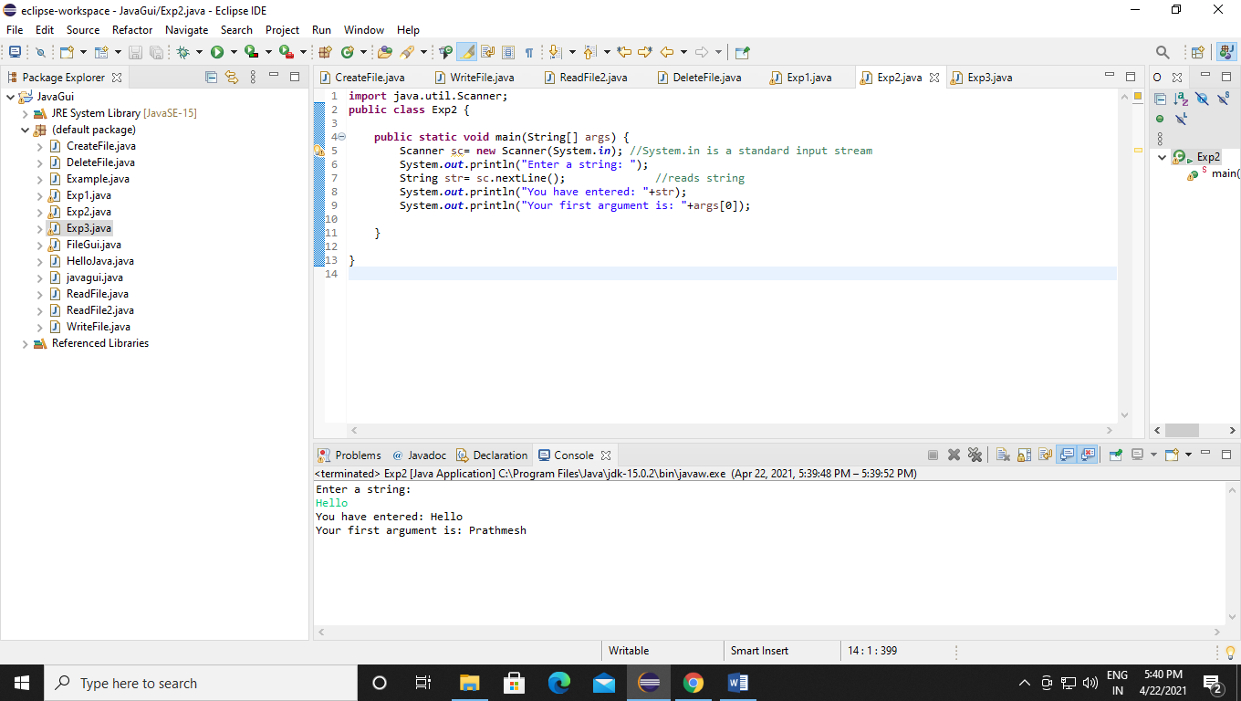

Q3. Write a Java Program to add two numbers entered as string by the user and sum of numbers passed by the command line argument.

Code:-

**import** java.util.Scanner;

**public** **class** Exp3 {

**public** **static** **void** main(String[] args) {

System.***out***.println("Enter the string numbers: ");

Scanner input = **new** Scanner(System.***in***);

String x = input.next();

String y = input.next();

String z = x + y;

System.***out***.println("The addition of two string numbers is: "+z);

**int** a;

**int** b;

**int** c;

a=Integer.*parseInt*(args[0]);

b=Integer.*parseInt*(args[0]);

c=a+b;

System.***out***.println("sum of " + a + " and " + b +" is " +c);

}

}

Output:-

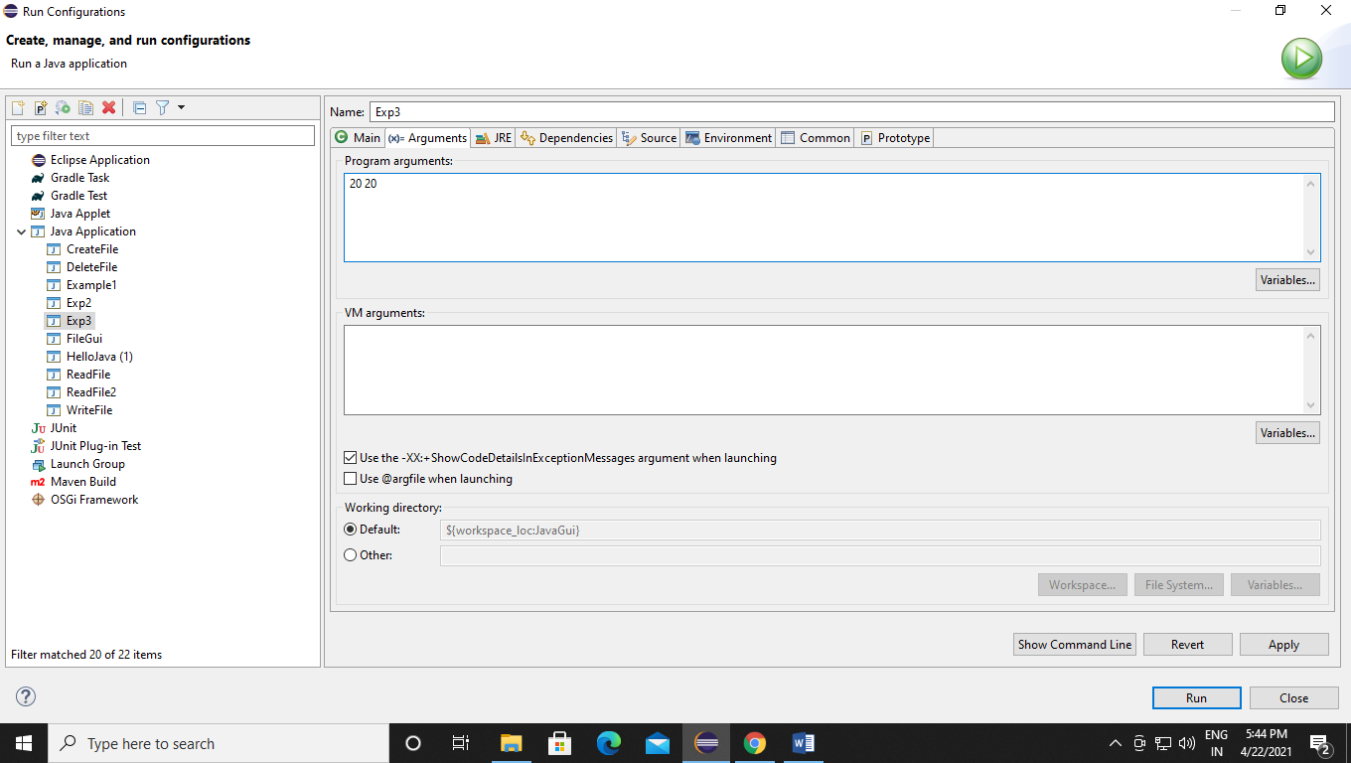

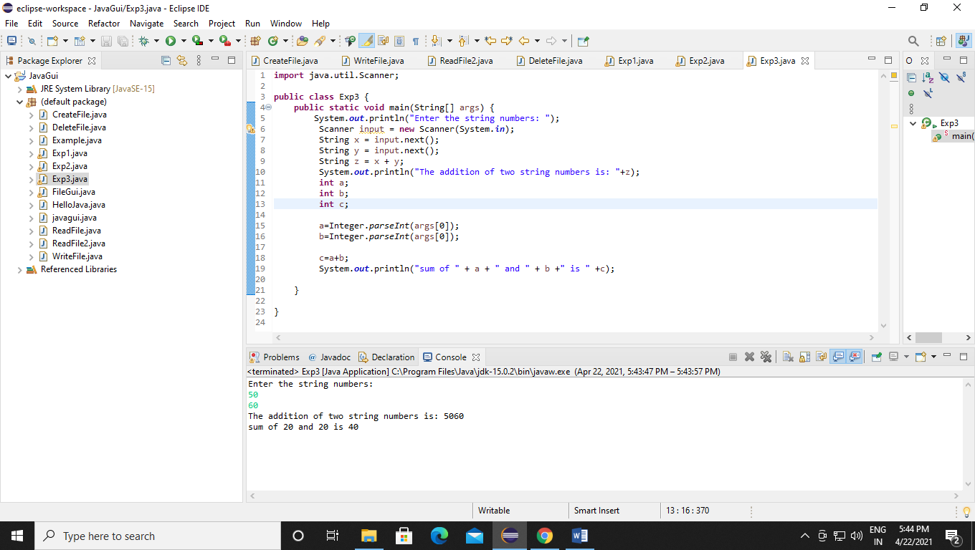

Q4. Write a Java Program to sort (Bubble Sort) the marks of a student entered by the user.

Code:-

**import** java.util.Scanner;

**public** **class** Exp4 {

**public** **static** **void** main(String []args) {

**int** num, i, j, temp;

Scanner input = **new** Scanner(System.***in***);

System.***out***.println("Enter the total subjects of the Student to sort:");

num = input.nextInt();

**int** array[] = **new** **int**[num];

System.***out***.println("Enter " + num + " subjects marks of the student: ");

**for** (i = 0; i < num; i++)

array[i] = input.nextInt();

**for** (i = 0; i < ( num - 1 ); i++) {

**for** (j = 0; j < num - i - 1; j++) {

**if** (array[j] > array[j+1])

{

temp = array[j];

array[j] = array[j+1];

array[j+1] = temp;

}

}

}

System.***out***.println("The marks of the student are:");

**for** (i = 0; i < num; i++)

System.***out***.println(array[i]);

}

}

Output:-

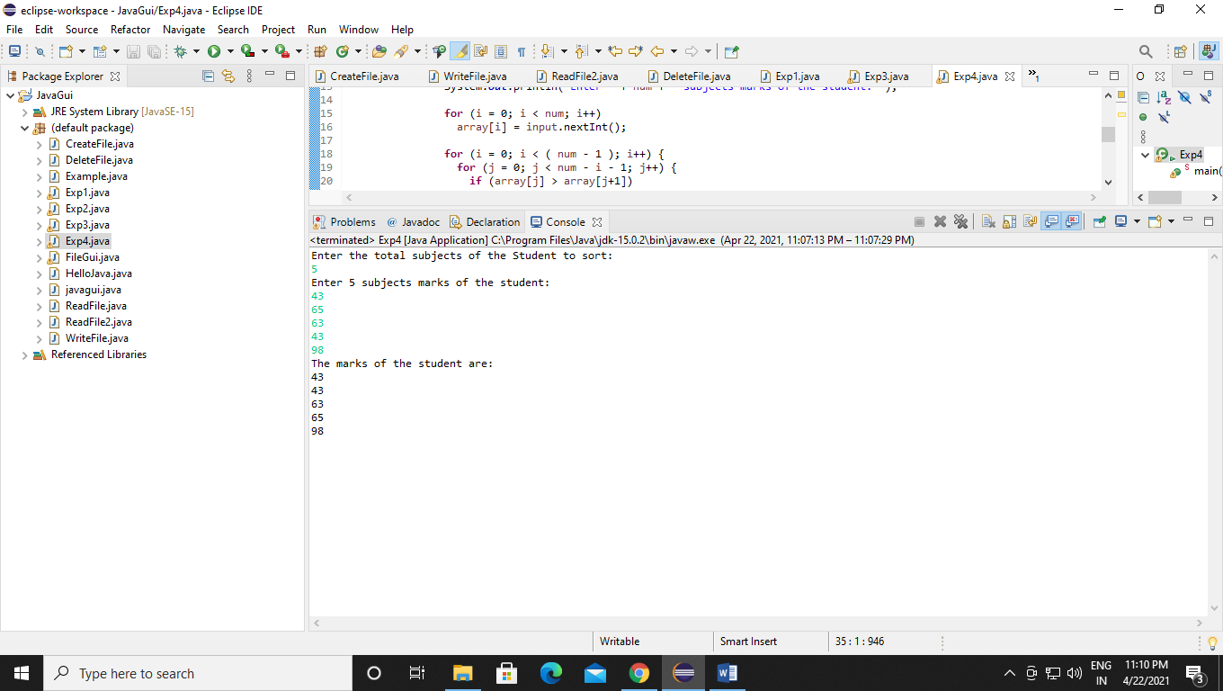

Q5. Write a Java Program to perform addition using a default and a parameterized constructor. Also sort the array of marks entered by the user and find the min and max on the array.

Code:-

**public** **class** Exp5 {

**public** **static** **void** main(String[] args) {

//Creating object of class using default constructor

DefaultConstructorExample object1 = **new** DefaultConstructorExample();

object1.doAddition();

//Creating object of class using parameterized constructor

ParameterizedConstructorExample object2 = **new** ParameterizedConstructorExample(100,200);

object2.doAddition();

}

}

**class** DefaultConstructorExample{

**int** num1 = 5, num2 = 10, result;

**int** doAddition(){

result = num1+num2;

System.***out***.println("---This is the output is Default and parametrized constructor---");

System.***out***.println("This method is called using a default constructor:" +result);

**return** result;

}

}

**class** ParameterizedConstructorExample{

**int** num1, num2, result;

**public** ParameterizedConstructorExample(**int** num1, **int** num2) {

**this**.num1 = num1;

**this**.num2 = num2;

}

**int** doAddition(){

result = num1+num2;

System.***out***.println("This method is called using a parameterized constructor:" +result);

**return** result;

}

}

Output:-

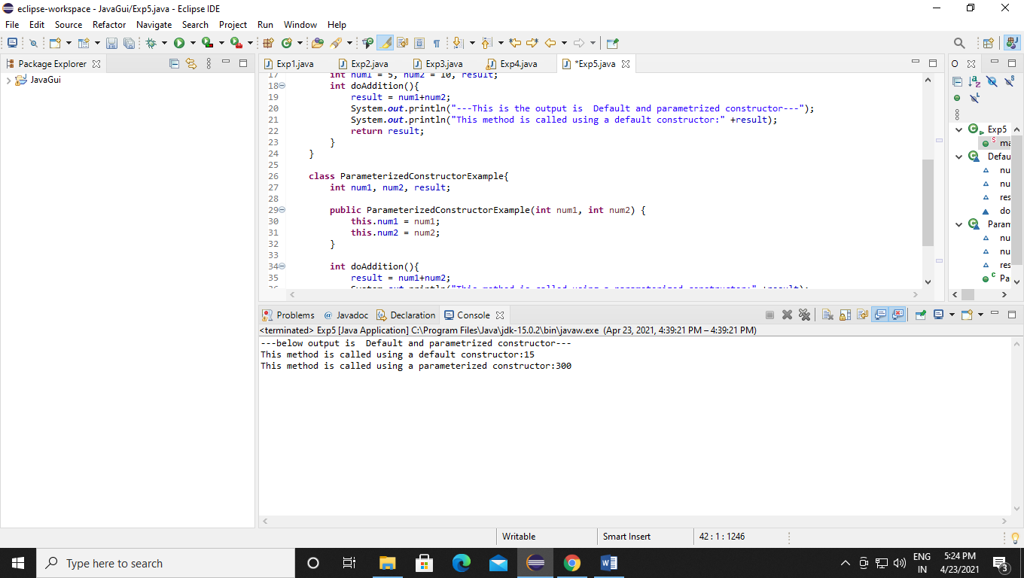

Q6. Write a Java Program to perform inheritance and multiple inheritance (Interface).

Code:-

public class Animal {

void eat(){System.out.println("eating...");}

}

class Dog extends Animal{

void bark(){System.out.println("barking...");}

}

class BabyDog extends Dog{

void weep(){System.out.println("weeping...");}

}

class TestInheritance2{

public static void main(String args[]){

BabyDog d=new BabyDog();

d.weep();

d.bark();

d.eat();

}}

Output:-

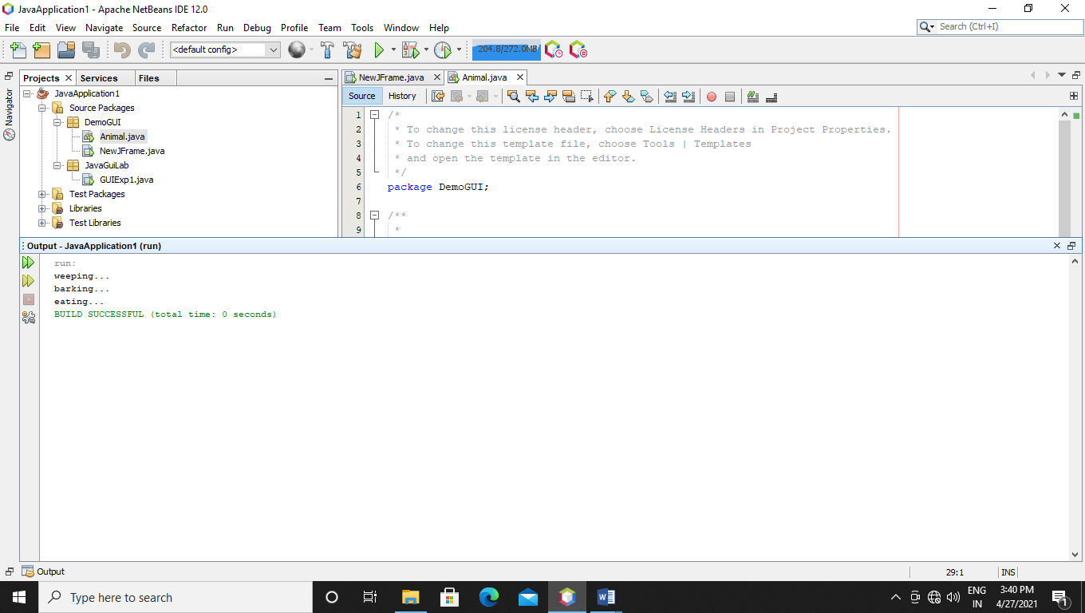

Q7 Write a program in java for creating file using file handling.

Code:-

import java.io.File;

import java.io.IOException;

public class CreateFile {

public static void main(String[] args) {

try {

File Obj = new File("C:\\Users\\prathmesha\\Desktop\\java\\example.txt");

if (Obj.createNewFile()) {

System.out.println("The File has been created : " + Obj.getName());

} else {

System.out.println("File already exists.");

}

} catch (IOException e) {

System.out.println("An error occurred.");

e.printStackTrace();

}

}

}

Output:-

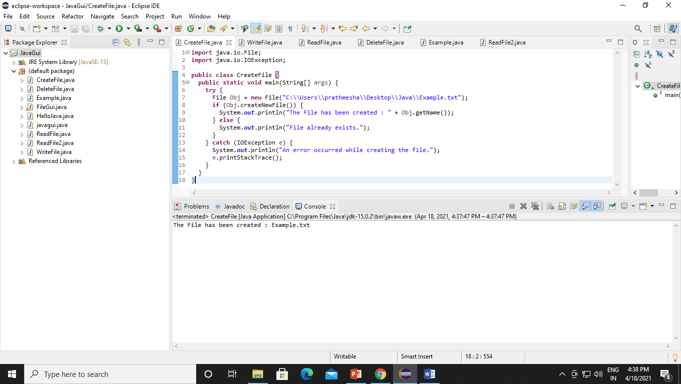

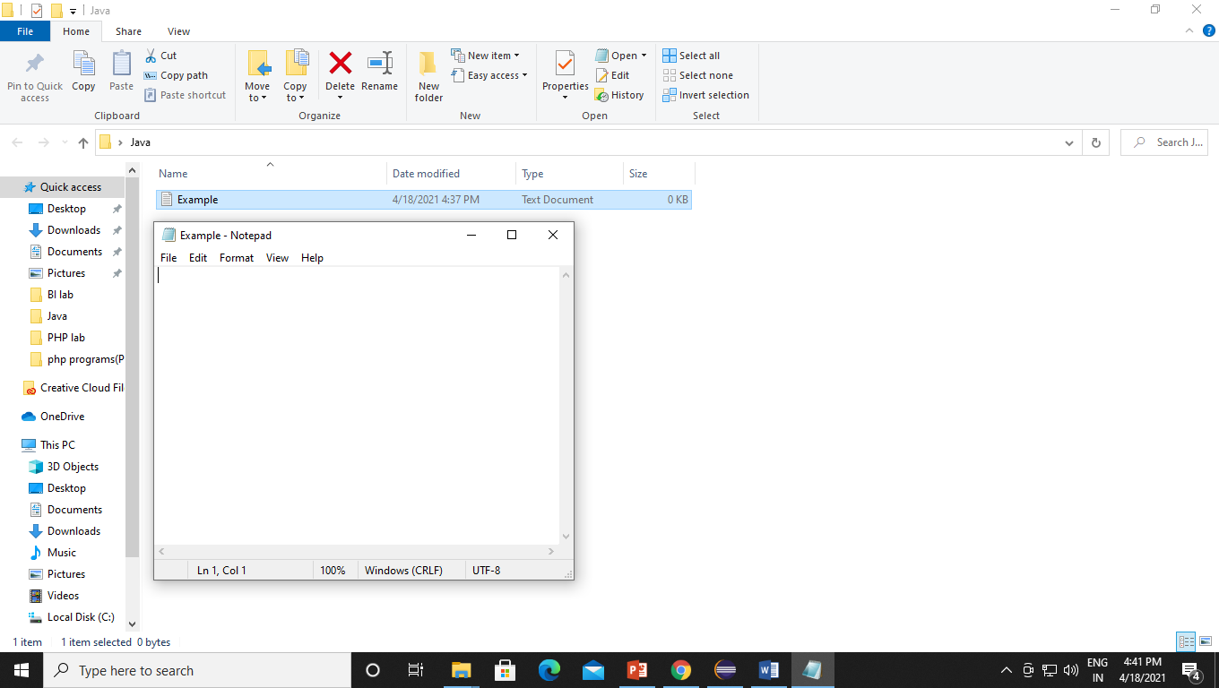

Q8. Write a program in java for writing in a file.

Code:-

import java.io.FileWriter;

import java.io.IOException;

public class WriteFile {

public static void main(String[] args) {

try {

FileWriter myFile = new FileWriter("C:\\\\Users\\\\prathmesha\\\\Desktop\\\\java\\\\example.txt");

myFile.write("Prathmesh BCA SEM 4");

myFile.close();

System.out.println("The file has been wrote successfully !!!.");

} catch (IOException e) {

System.out.println("An error occurred.");

e.printStackTrace();

}

}

}

Output:-

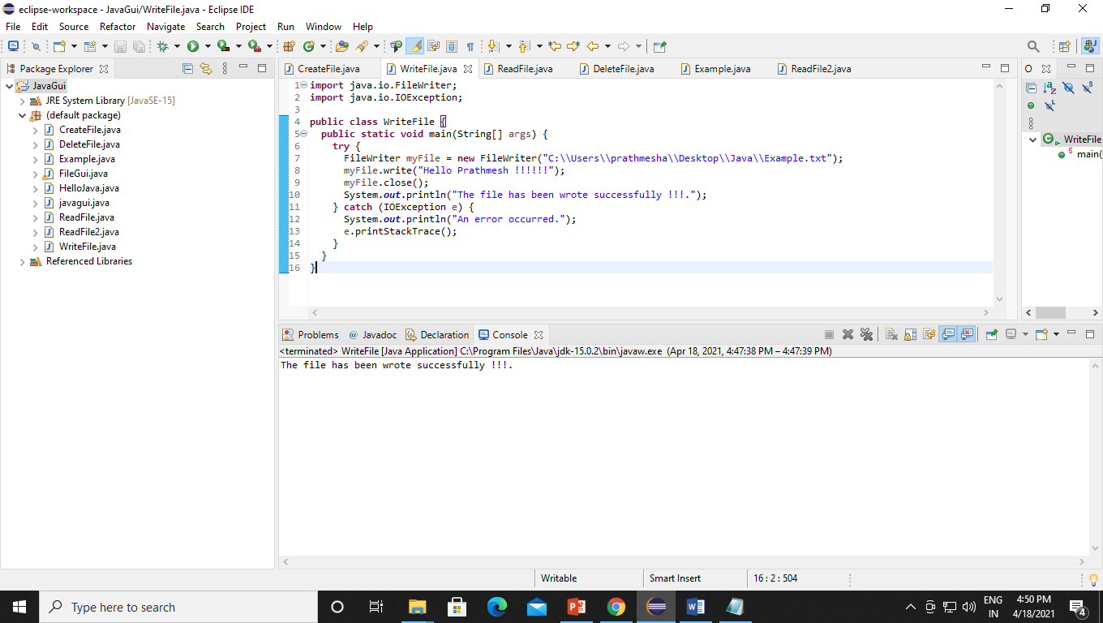

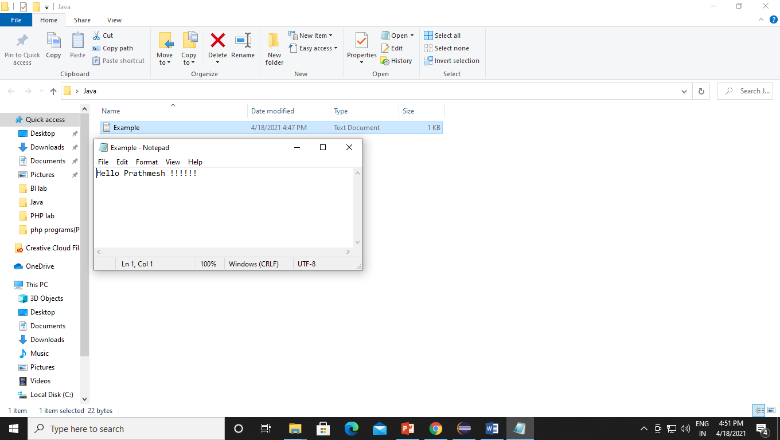

Q9 Write a program in a java for reading a file.

Code:-

**import** java.io.File;

**import** java.io.FileNotFoundException;

**import** java.util.Scanner;

**public** **class** ReadFile2 {

**public** **static** **void** main(String[] args) {

File Obj = **new** File("C:\\Users\\prathmesha\\Desktop\\java\\example.txt");

**try** {

Scanner Read = **new** Scanner(Obj);

**while** (Read.hasNextLine()) {

String data = Read.nextLine();

System.***out***.println("Content of the file: " + data);

}

Read.close();

} **catch** (FileNotFoundException e) {

System.***out***.println("An error occurred.");

e.printStackTrace();

}

**if** (Obj.exists()) {

System.***out***.println("File name: " + Obj.getName());

System.***out***.println("Absolute path: " + Obj.getAbsolutePath());

System.***out***.println("Writeable: " + Obj.canWrite());

System.***out***.println("Readable " + Obj.canRead());

System.***out***.println("File size in bytes " + Obj.length());

} **else** {

System.***out***.println("The file does not exist.");

}

}

}

Output:-

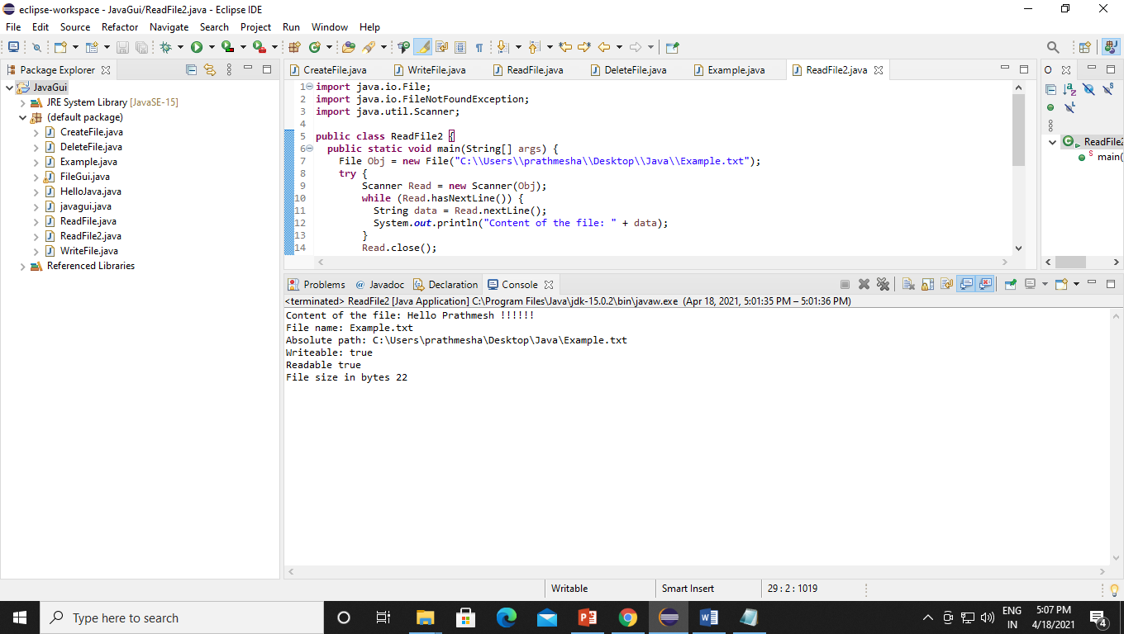

Q10 Write a program in java for deleting a file.

Code:-

**import** java.io.File;

**public** **class** DeleteFile {

**public** **static** **void** main(String[] args) {

File Obj = **new** File("C:\\Users\\prathmesha\\Desktop\\java\\example.txt");

**if** (Obj.delete()) {

System.***out***.println("Deleted the file: " + Obj.getName());

} **else** {

System.***out***.println("Failed to delete the file.");

}

}

}

Output:-

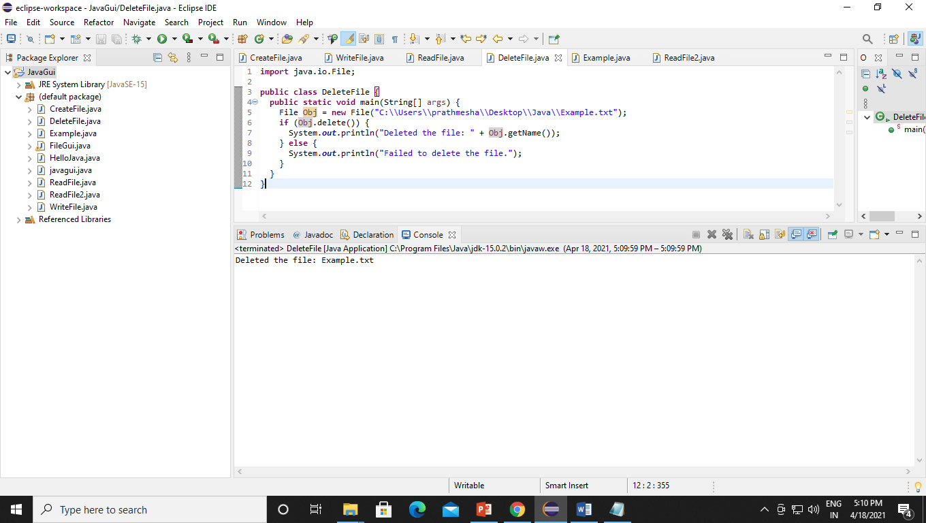

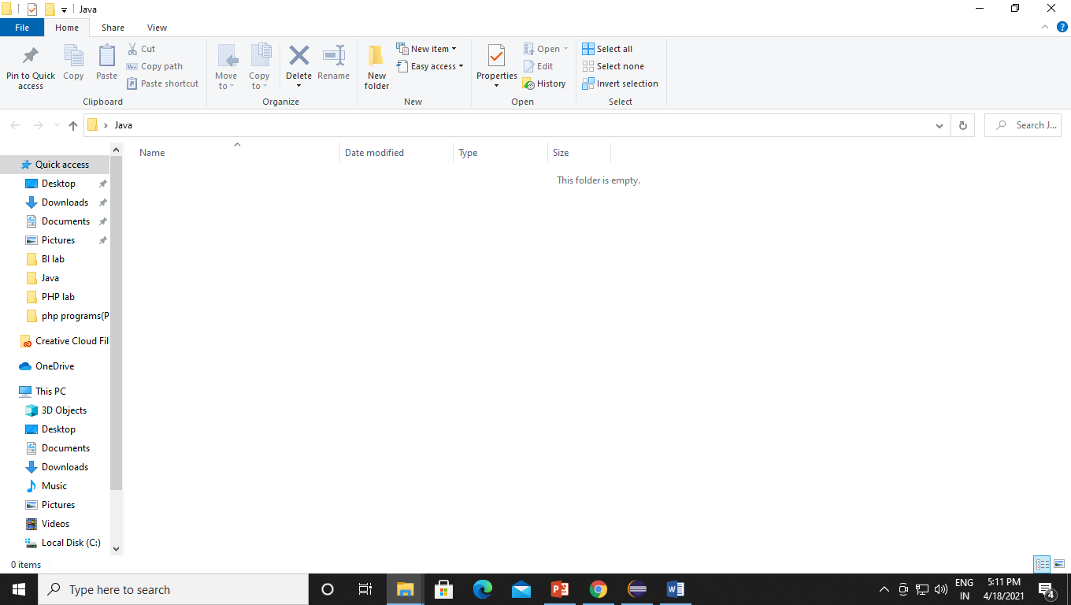

Q11 Write a Java program to display number of mouse clicked.

Code:-

package JavaGuiLab;

/**

*

* @author prathmesha

*/

public class GUIExp1 extends javax.swing.JFrame {

/**

* Creates new form GUIExp1

*/

public GUIExp1() {

initComponents();

}

/**

* This method is called from within the constructor to initialize the form.

* WARNING: Do NOT modify this code. The content of this method is always

* regenerated by the Form Editor.

*/

@SuppressWarnings("unchecked")

// <editor-fold defaultstate="collapsed" desc="Generated Code">

private void initComponents() {

jButton1 = new javax.swing.JButton();

jTextField1 = new javax.swing.JTextField();

setDefaultCloseOperation(javax.swing.WindowConstants.EXIT_ON_CLOSE);

jButton1.setText("Click me :-)");

jButton1.addMouseListener(new java.awt.event.MouseAdapter() {

public void mouseClicked(java.awt.event.MouseEvent evt) {

jButton1MouseClicked(evt);

}

});

jButton1.addActionListener(new java.awt.event.ActionListener() {

public void actionPerformed(java.awt.event.ActionEvent evt) {

jButton1ActionPerformed(evt);

}

});

javax.swing.GroupLayout layout = new javax.swing.GroupLayout(getContentPane());

getContentPane().setLayout(layout);

layout.setHorizontalGroup(

layout.createParallelGroup(javax.swing.GroupLayout.Alignment.LEADING)

.addGroup(javax.swing.GroupLayout.Alignment.TRAILING, layout.createSequentialGroup()

.addContainerGap()

.addComponent(jButton1, javax.swing.GroupLayout.DEFAULT_SIZE, javax.swing.GroupLayout.DEFAULT_SIZE, Short.MAX_VALUE)

.addContainerGap())

.addGroup(layout.createSequentialGroup()

.addGap(106, 106, 106)

.addComponent(jTextField1, javax.swing.GroupLayout.PREFERRED_SIZE, 186, javax.swing.GroupLayout.PREFERRED_SIZE)

.addContainerGap(108, Short.MAX_VALUE))

);

layout.setVerticalGroup(

layout.createParallelGroup(javax.swing.GroupLayout.Alignment.LEADING)

.addGroup(javax.swing.GroupLayout.Alignment.TRAILING, layout.createSequentialGroup()

.addContainerGap(105, Short.MAX_VALUE)

.addComponent(jTextField1, javax.swing.GroupLayout.PREFERRED_SIZE, 57, javax.swing.GroupLayout.PREFERRED_SIZE)

.addGap(57, 57, 57)

.addComponent(jButton1)

.addGap(58, 58, 58))

);

pack();

}// </editor-fold>

private void jButton1MouseClicked(java.awt.event.MouseEvent evt) {

// TODO add your handling code here:

if (evt.getClickCount() == 3) {

jTextField1.setText("Mouse Clicked triple times");

}

else if(evt.getClickCount() == 2){

jTextField1.setText("Mouse Clicked double times");

}

else if(evt.getClickCount() == 1){

jTextField1.setText("Mouse Clicked one time");

}

}

private void jButton1ActionPerformed(java.awt.event.ActionEvent evt) {

// TODO add your handling code here:

}

/**

* @param args the command line arguments

*/

public static void main(String args[]) {

/* Set the Nimbus look and feel */

//<editor-fold defaultstate="collapsed" desc=" Look and feel setting code (optional) ">

/* If Nimbus (introduced in Java SE 6) is not available, stay with the default look and feel.

* For details see http://download.oracle.com/javase/tutorial/uiswing/lookandfeel/plaf.html

*/

try {

for (javax.swing.UIManager.LookAndFeelInfo info : javax.swing.UIManager.getInstalledLookAndFeels()) {

if ("Nimbus".equals(info.getName())) {

javax.swing.UIManager.setLookAndFeel(info.getClassName());

break;

}

}

} catch (ClassNotFoundException ex) {

java.util.logging.Logger.getLogger(GUIExp1.class.getName()).log(java.util.logging.Level.SEVERE, null, ex);

} catch (InstantiationException ex) {

java.util.logging.Logger.getLogger(GUIExp1.class.getName()).log(java.util.logging.Level.SEVERE, null, ex);

} catch (IllegalAccessException ex) {

java.util.logging.Logger.getLogger(GUIExp1.class.getName()).log(java.util.logging.Level.SEVERE, null, ex);

} catch (javax.swing.UnsupportedLookAndFeelException ex) {

java.util.logging.Logger.getLogger(GUIExp1.class.getName()).log(java.util.logging.Level.SEVERE, null, ex);

}

//</editor-fold>

/* Create and display the form */

java.awt.EventQueue.invokeLater(new Runnable() {

public void run() {

new GUIExp1().setVisible(true);

}

});

}

// Variables declaration - do not modify

private javax.swing.JButton jButton1;

private javax.swing.JTextField jTextField1;

// End of variables declaration

}

Output:-

For one time:-

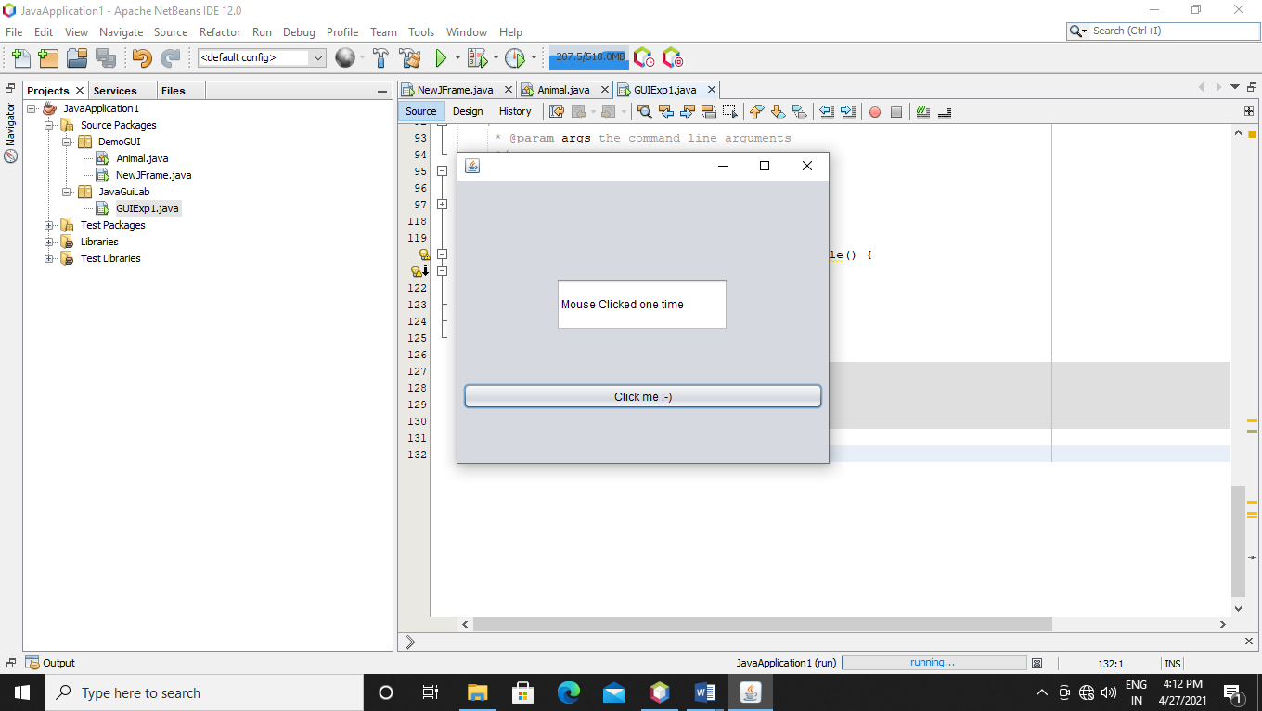

For two time:-

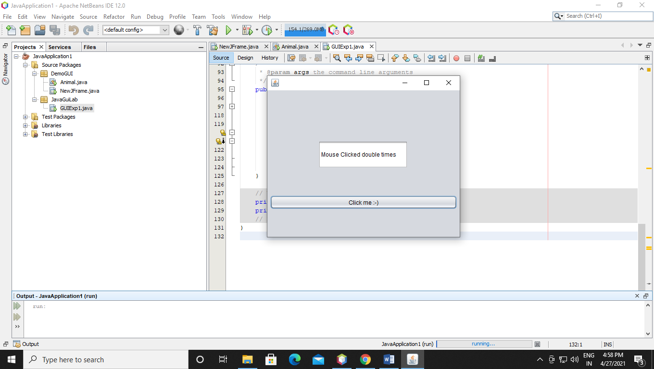

For three time:-

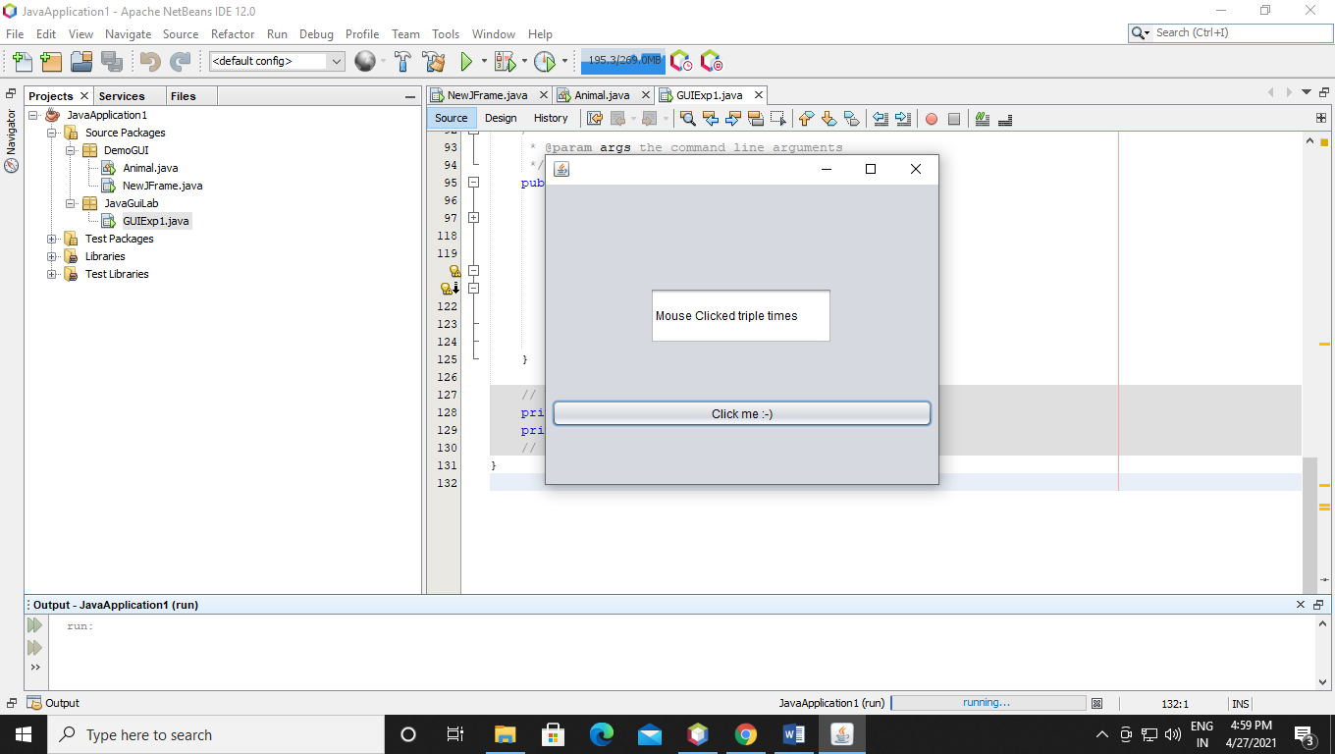

Q12. Write a Java Program to implement GUI and display the following keys 17

• Perform addition and factorial. 17

• Show output of factorial on a text pane. 17

• Show output of addition on a text pane and a Dialogue Message.

Code:-

package DemoGUI;

import javax.swing.JOptionPane;

/**

*

* @author prathmesha

*/

public class NewJFrame extends javax.swing.JFrame {

/**

* Creates new form NewJFrame

*/

public NewJFrame() {

initComponents();

}

/**

* This method is called from within the constructor to initialize the form.

* WARNING: Do NOT modify this code. The content of this method is always

* regenerated by the Form Editor.

*/

@SuppressWarnings("unchecked")

// <editor-fold defaultstate="collapsed" desc="Generated Code">

private void initComponents() {

jLabel1 = new javax.swing.JLabel();

jTextField1 = new javax.swing.JTextField();

jLabel2 = new javax.swing.JLabel();

jTextField2 = new javax.swing.JTextField();

jButton1 = new javax.swing.JButton();

jLabel4 = new javax.swing.JLabel();

jLabel5 = new javax.swing.JLabel();

jLabel6 = new javax.swing.JLabel();

jTextField3 = new javax.swing.JTextField();

jButton2 = new javax.swing.JButton();

jScrollPane1 = new javax.swing.JScrollPane();

jTextPane1 = new javax.swing.JTextPane();

jScrollPane2 = new javax.swing.JScrollPane();

jTextPane2 = new javax.swing.JTextPane();

setDefaultCloseOperation(javax.swing.WindowConstants.EXIT_ON_CLOSE);

jLabel1.setText("Num 1:-");

jTextField1.addActionListener(new java.awt.event.ActionListener() {

public void actionPerformed(java.awt.event.ActionEvent evt) {

jTextField1ActionPerformed(evt);

}

});

jLabel2.setText("Num 2:-");

jTextField2.addActionListener(new java.awt.event.ActionListener() {

public void actionPerformed(java.awt.event.ActionEvent evt) {

jTextField2ActionPerformed(evt);

}

});

jButton1.setText("Result");

jButton1.addActionListener(new java.awt.event.ActionListener() {

public void actionPerformed(java.awt.event.ActionEvent evt) {

jButton1ActionPerformed(evt);

}

});

jLabel4.setText("For Addition of two numbers:");

jLabel5.setText("For Factorial of a number:");

jLabel6.setText("Num 3:-");

jTextField3.addActionListener(new java.awt.event.ActionListener() {

public void actionPerformed(java.awt.event.ActionEvent evt) {

jTextField3ActionPerformed(evt);

}

});

jButton2.setText("Solution");

jButton2.addActionListener(new java.awt.event.ActionListener() {

public void actionPerformed(java.awt.event.ActionEvent evt) {

jButton2ActionPerformed(evt);

}

});

jScrollPane1.setViewportView(jTextPane1);

jScrollPane2.setViewportView(jTextPane2);

javax.swing.GroupLayout layout = new javax.swing.GroupLayout(getContentPane());

getContentPane().setLayout(layout);

layout.setHorizontalGroup(

layout.createParallelGroup(javax.swing.GroupLayout.Alignment.LEADING)

.addGroup(layout.createSequentialGroup()

.addGap(54, 54, 54)

.addGroup(layout.createParallelGroup(javax.swing.GroupLayout.Alignment.LEADING, false)

.addGroup(layout.createSequentialGroup()

.addGroup(layout.createParallelGroup(javax.swing.GroupLayout.Alignment.LEADING, false)

.addComponent(jLabel1, javax.swing.GroupLayout.DEFAULT_SIZE, 39, Short.MAX_VALUE)

.addComponent(jLabel2, javax.swing.GroupLayout.DEFAULT_SIZE, javax.swing.GroupLayout.DEFAULT_SIZE, Short.MAX_VALUE))

.addPreferredGap(javax.swing.LayoutStyle.ComponentPlacement.RELATED)

.addGroup(layout.createParallelGroup(javax.swing.GroupLayout.Alignment.LEADING, false)

.addComponent(jTextField2, javax.swing.GroupLayout.DEFAULT_SIZE, 57, Short.MAX_VALUE)

.addComponent(jTextField1))

.addPreferredGap(javax.swing.LayoutStyle.ComponentPlacement.RELATED)

.addComponent(jButton1)

.addGap(28, 28, 28)

.addComponent(jScrollPane1, javax.swing.GroupLayout.PREFERRED_SIZE, 95, javax.swing.GroupLayout.PREFERRED_SIZE))

.addComponent(jLabel5, javax.swing.GroupLayout.PREFERRED_SIZE, 140, javax.swing.GroupLayout.PREFERRED_SIZE)

.addGroup(layout.createSequentialGroup()

.addComponent(jLabel6, javax.swing.GroupLayout.PREFERRED_SIZE, 45, javax.swing.GroupLayout.PREFERRED_SIZE)

.addPreferredGap(javax.swing.LayoutStyle.ComponentPlacement.RELATED)

.addComponent(jTextField3, javax.swing.GroupLayout.PREFERRED_SIZE, 63, javax.swing.GroupLayout.PREFERRED_SIZE)

.addGap(18, 18, 18)

.addComponent(jButton2)

.addGap(18, 18, 18)

.addComponent(jScrollPane2))

.addComponent(jLabel4, javax.swing.GroupLayout.PREFERRED_SIZE, 199, javax.swing.GroupLayout.PREFERRED_SIZE))

.addContainerGap(278, Short.MAX_VALUE))

);

layout.setVerticalGroup(

layout.createParallelGroup(javax.swing.GroupLayout.Alignment.LEADING)

.addGroup(layout.createSequentialGroup()

.addContainerGap()

.addComponent(jLabel4)

.addGroup(layout.createParallelGroup(javax.swing.GroupLayout.Alignment.LEADING)

.addGroup(layout.createSequentialGroup()

.addGap(11, 11, 11)

.addGroup(layout.createParallelGroup(javax.swing.GroupLayout.Alignment.BASELINE)

.addComponent(jLabel1, javax.swing.GroupLayout.PREFERRED_SIZE, 29, javax.swing.GroupLayout.PREFERRED_SIZE)

.addComponent(jTextField1, javax.swing.GroupLayout.PREFERRED_SIZE, 29, javax.swing.GroupLayout.PREFERRED_SIZE))

.addGap(18, 18, 18)

.addGroup(layout.createParallelGroup(javax.swing.GroupLayout.Alignment.BASELINE)

.addComponent(jLabel2, javax.swing.GroupLayout.PREFERRED_SIZE, 29, javax.swing.GroupLayout.PREFERRED_SIZE)

.addComponent(jTextField2, javax.swing.GroupLayout.PREFERRED_SIZE, 29, javax.swing.GroupLayout.PREFERRED_SIZE)))

.addGroup(layout.createSequentialGroup()

.addGap(38, 38, 38)

.addGroup(layout.createParallelGroup(javax.swing.GroupLayout.Alignment.LEADING, false)

.addComponent(jScrollPane1)

.addComponent(jButton1, javax.swing.GroupLayout.DEFAULT_SIZE, javax.swing.GroupLayout.DEFAULT_SIZE, Short.MAX_VALUE))))

.addGap(36, 36, 36)

.addComponent(jLabel5)

.addGap(18, 18, 18)

.addGroup(layout.createParallelGroup(javax.swing.GroupLayout.Alignment.LEADING)

.addGroup(layout.createParallelGroup(javax.swing.GroupLayout.Alignment.BASELINE)

.addComponent(jLabel6, javax.swing.GroupLayout.PREFERRED_SIZE, 31, javax.swing.GroupLayout.PREFERRED_SIZE)

.addComponent(jTextField3, javax.swing.GroupLayout.PREFERRED_SIZE, 31, javax.swing.GroupLayout.PREFERRED_SIZE)

.addComponent(jButton2))

.addComponent(jScrollPane2, javax.swing.GroupLayout.PREFERRED_SIZE, 31, javax.swing.GroupLayout.PREFERRED_SIZE))

.addContainerGap(134, Short.MAX_VALUE))

);

pack();

}// </editor-fold>

private void jTextField1ActionPerformed(java.awt.event.ActionEvent evt) {

// TODO add your handling code here:

}

private void jTextField2ActionPerformed(java.awt.event.ActionEvent evt) {

// TODO add your handling code here:

}

private void jButton1ActionPerformed(java.awt.event.ActionEvent evt) {

// TODO add your handling code here:

float a, b ,result;

a = Float.parseFloat(jTextField1.getText());

b = Float.parseFloat(jTextField2.getText());

result = a + b;

jTextPane1.setText(String.valueOf(result));

if(jTextPane1.getText().equals(result)){

}

}

private void jTextField3ActionPerformed(java.awt.event.ActionEvent evt) {

// TODO add your handling code here:

}

private void jButton2ActionPerformed(java.awt.event.ActionEvent evt) {

// TODO add your handling code here:

int i,fact=1;

int number = Integer.parseInt(jTextField3.getText());

for(i=1;i<=number;i++){

fact=fact*i;

}

jTextPane2.setText(String.valueOf(fact));

}

/**

* @param args the command line arguments

*/

public static void main(String args[]) {

/* Set the Nimbus look and feel */

//<editor-fold defaultstate="collapsed" desc=" Look and feel setting code (optional) ">

/* If Nimbus (introduced in Java SE 6) is not available, stay with the default look and feel.

* For details see http://download.oracle.com/javase/tutorial/uiswing/lookandfeel/plaf.html

*/

try {

for (javax.swing.UIManager.LookAndFeelInfo info : javax.swing.UIManager.getInstalledLookAndFeels()) {

if ("Nimbus".equals(info.getName())) {

javax.swing.UIManager.setLookAndFeel(info.getClassName());

break;

}

}

} catch (ClassNotFoundException ex) {

java.util.logging.Logger.getLogger(NewJFrame.class.getName()).log(java.util.logging.Level.SEVERE, null, ex);

} catch (InstantiationException ex) {

java.util.logging.Logger.getLogger(NewJFrame.class.getName()).log(java.util.logging.Level.SEVERE, null, ex);

} catch (IllegalAccessException ex) {

java.util.logging.Logger.getLogger(NewJFrame.class.getName()).log(java.util.logging.Level.SEVERE, null, ex);

} catch (javax.swing.UnsupportedLookAndFeelException ex) {

java.util.logging.Logger.getLogger(NewJFrame.class.getName()).log(java.util.logging.Level.SEVERE, null, ex);

}

//</editor-fold>

/* Create and display the form */

java.awt.EventQueue.invokeLater(new Runnable() {

public void run() {

new NewJFrame().setVisible(true);

}

});

}

// Variables declaration - do not modify

private javax.swing.JButton jButton1;

private javax.swing.JButton jButton2;

private javax.swing.JLabel jLabel1;

private javax.swing.JLabel jLabel2;

private javax.swing.JLabel jLabel4;

private javax.swing.JLabel jLabel5;

private javax.swing.JLabel jLabel6;

private javax.swing.JScrollPane jScrollPane1;

private javax.swing.JScrollPane jScrollPane2;

private javax.swing.JTextField jTextField1;

private javax.swing.JTextField jTextField2;

private javax.swing.JTextField jTextField3;

private javax.swing.JTextPane jTextPane1;

private javax.swing.JTextPane jTextPane2;

// End of variables declaration

}

Output:-

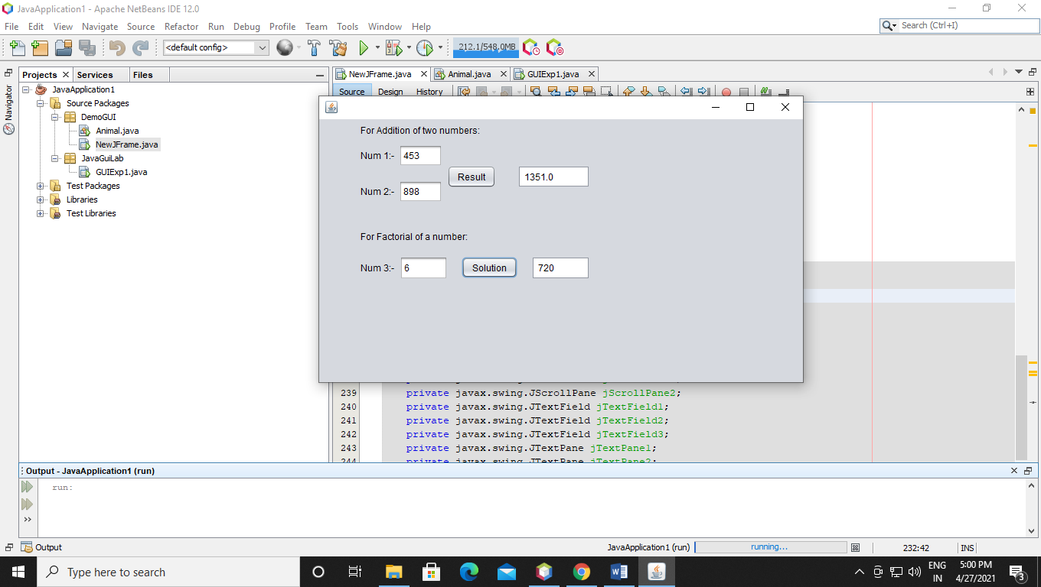

Q13 Write a java program to Enter Gender and display it in a Dialogue Message

Code:-

package JavaGuiLab;

/**

*

* @author prathmesha

*/

import javax.swing.JOptionPane;

public class Gender {

public static void main(String[] args)

{

String name;

// Get the user's name.

name = JOptionPane.showInputDialog("What is your Gender? ");

// Display message

JOptionPane.showMessageDialog(null, "The gender is " + name);

}

}

Output:-

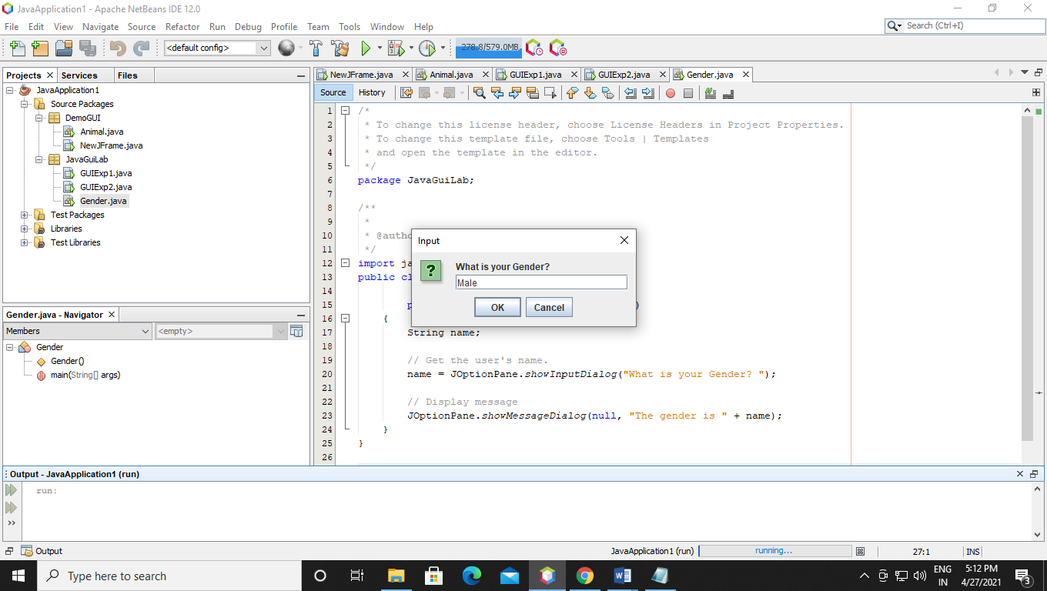

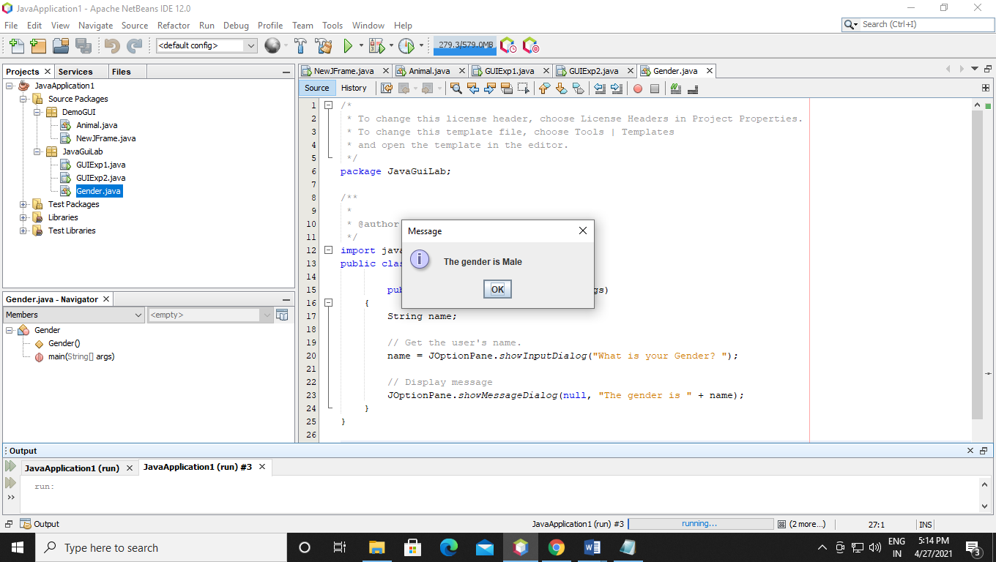

Q14. Write a java program to Display the x and y axis of the mouse

Code:-

package JavaGuiLab;

/**

*

* @author prathmesha

*/

import java.awt.*;

import java.awt.event.*;

public class MouseXY extends Frame implements MouseListener, MouseMotionListener

{

int x, y;

String str="";

public MouseXY()

{

addMouseListener(this);

addMouseMotionListener(this);

setSize(300, 300);

setVisible(true);

}

// override MouseListener five abstract methods

public void mousePressed(MouseEvent e)

{

x = e.getX();

y = e.getY();

str = "Mouse Pressed";

repaint();

}

public void mouseReleased(MouseEvent e)

{

x = e.getX();

y = e.getY();

str = "Mouse Released";

repaint();

}

public void mouseClicked(MouseEvent e)

{

x = e.getX();

y = e.getY();

str = "Mouse Clicked";

repaint();

}

public void mouseEntered(MouseEvent e)

{

x = e.getX();

y = e.getY();

str = "Mouse Entered";

repaint();

}

public void mouseExited(MouseEvent e)

{

x = e.getX();

y = e.getY();

str = "Mouse Exited";

repaint();

}

// override MouseMotionListener two abstract methods

public void mouseMoved(MouseEvent e)

{

x = e.getX();

y = e.getY();

str = "Mouse Moved";

repaint();

}

public void mouseDragged(MouseEvent e)

{

x = e.getX();

y = e.getY();

str = "Mouse dragged";

repaint();

}

public void paint(Graphics g)

{

g.setFont(new Font("Monospaced", Font.BOLD, 20));

g.fillOval(x, y, 10, 10); // gives the bullet

g.drawString(x + "," + y, x+10, y -10); // displays the x and y position

g.drawString(str, x+10, y+20); // displays the action performed

}

public static void main(String args[])

{

new MouseXY();

}

}

Output:-

Mouse Moved:-

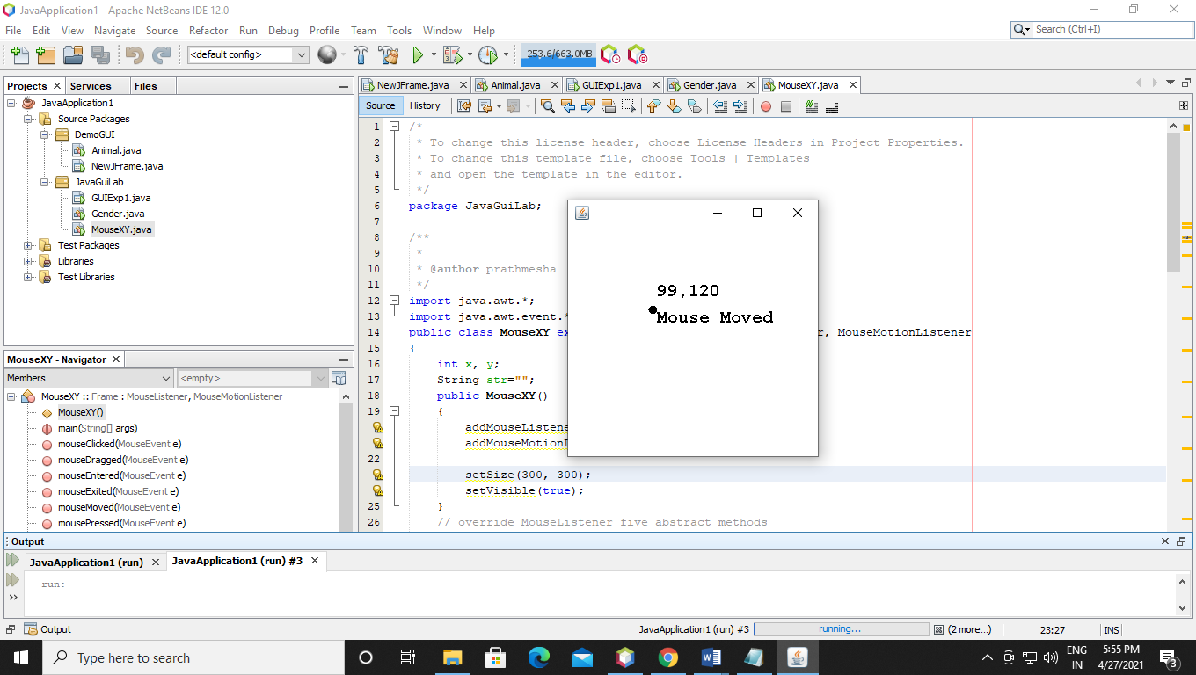

Mouse dragged:-

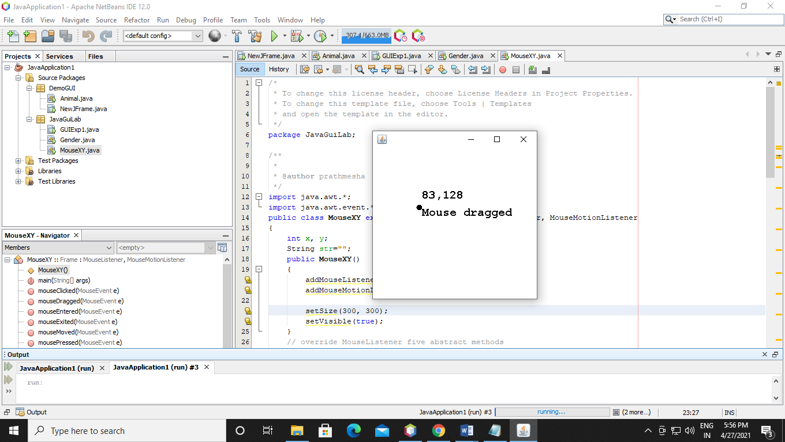

Mouse Pressed:-

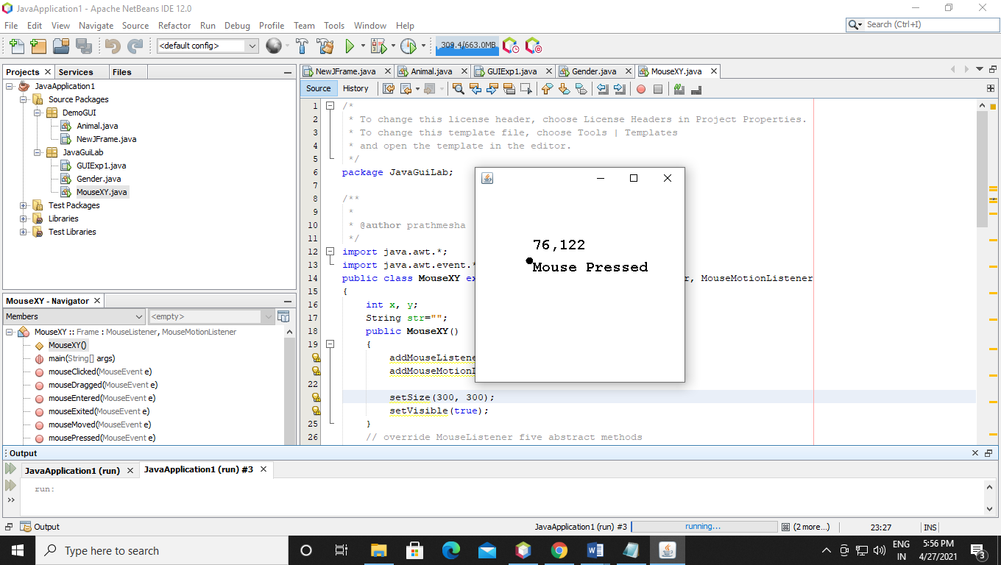

Mouse Clicked:-

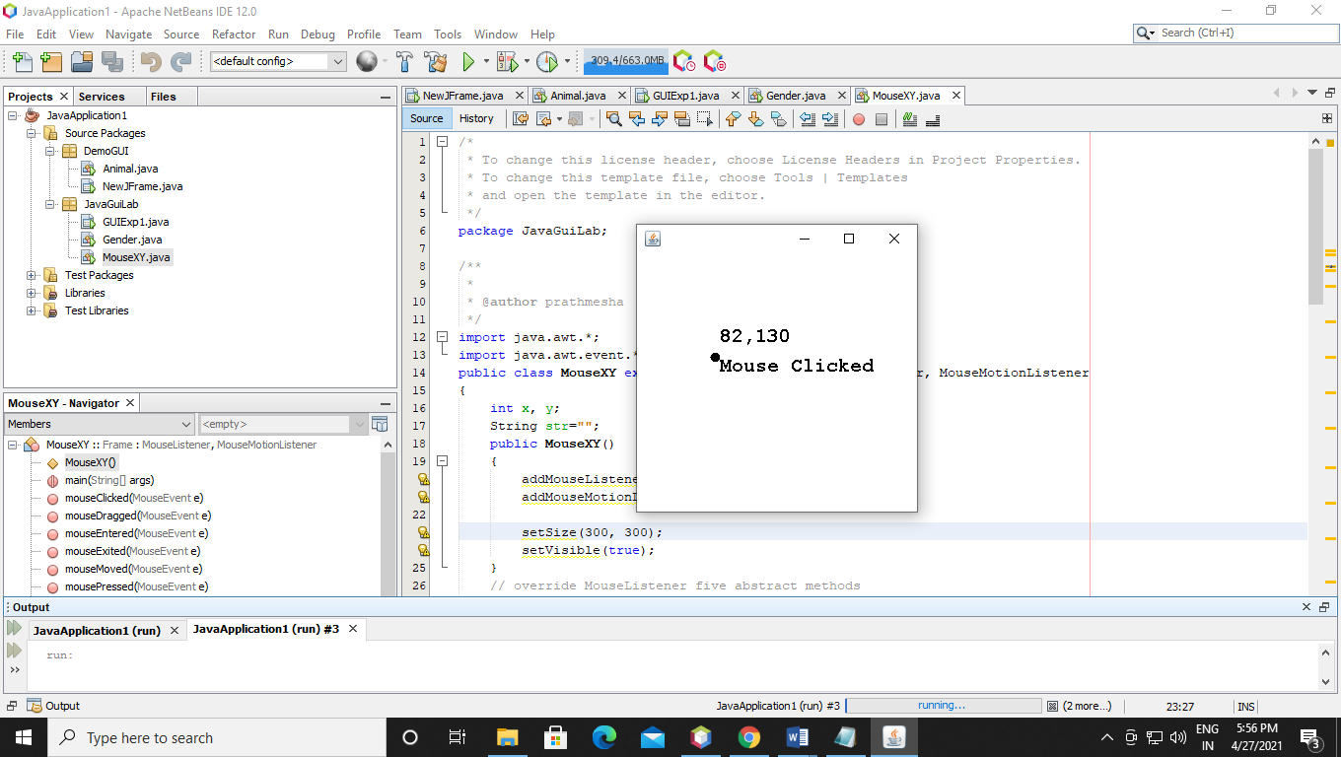

Mouse Released:-

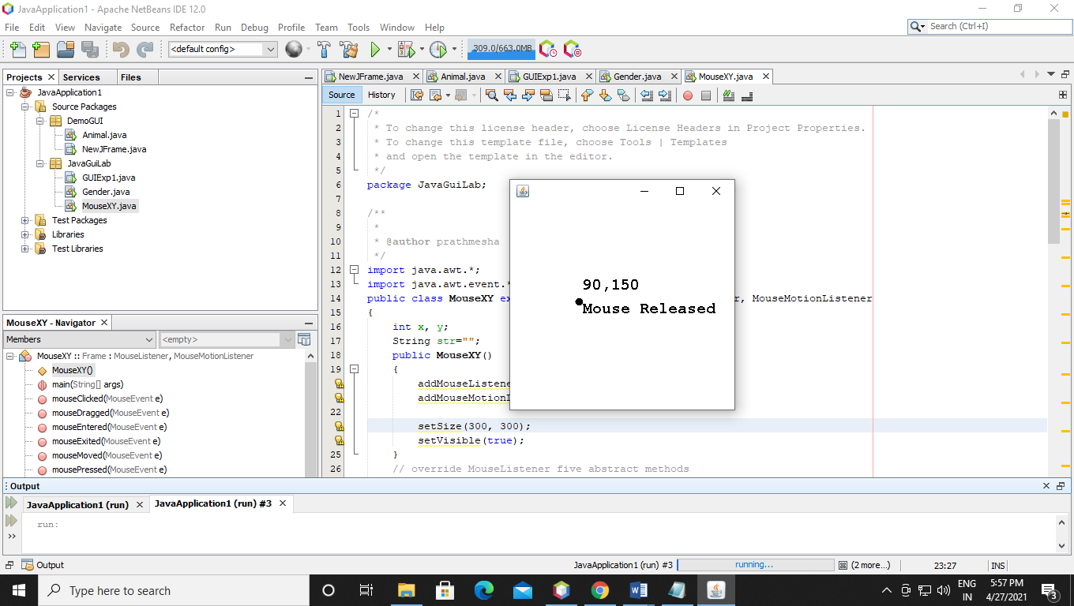

Mouse Exited:-

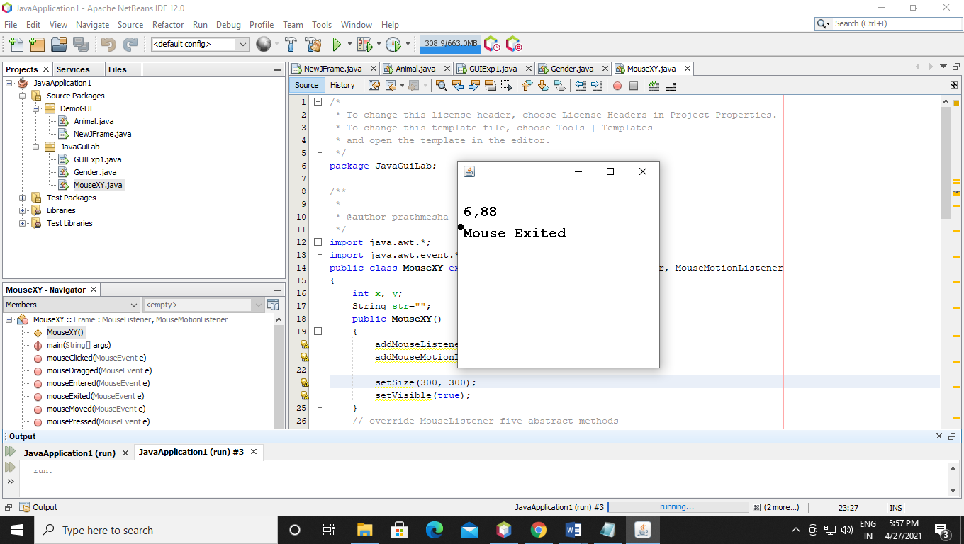

Q15. Write a java program to Show msg when mouse mouse move inside the panel

Code:-

package JavaGuiLab;

/**

*

* @author prathmesha

*/

import java.awt.*;

import java.awt.event.*;

import javax.swing.*;

public class MouseMovedMessage extends JFrame {

private JLabel label;

public MouseMovedMessage() {

setTitle("MouseOver Test");

setLayout(new FlowLayout());

label = new JLabel("Move the mouse moves over this label text");

label.setOpaque(true);

add(label);

label.addMouseListener(new MouseAdapter() {

public void mouseEntered(MouseEvent evt) {

Color c = label.getBackground(); // When the mouse moves over a label, the background color changed.

label.setBackground(label.getForeground());

label.setForeground(c);

}

public void mouseExited(MouseEvent evt) {

Color c = label.getBackground();

label.setBackground(label.getForeground());

label.setForeground(c);

}

});

setSize(400, 275);

setDefaultCloseOperation(JFrame.EXIT_ON_CLOSE);

setLocationRelativeTo(null);

setVisible(true);

}

public static void main(String[] args) {

new MouseMovedMessage();

}

}

Output:-

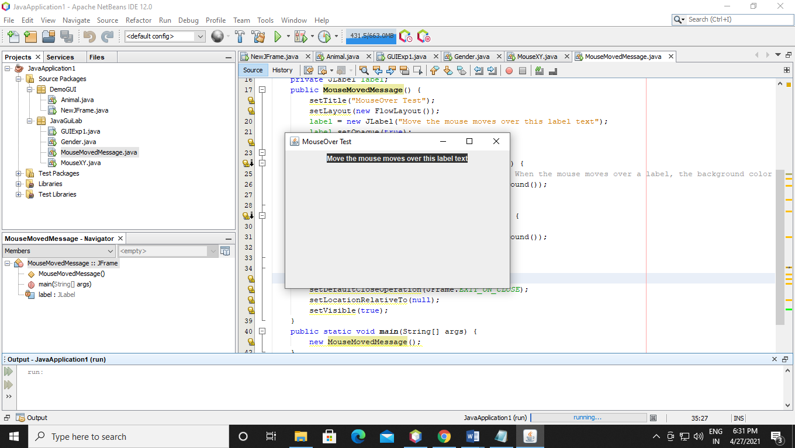

Q16 Write a program to display a Rectangle and Circle on mouseclick.

Code:-

package JavaGuiLab;

/**

*

* @author prathmesha

*/

import java.awt.BorderLayout;

import java.awt.Color;

import java.awt.EventQueue;

import java.awt.Graphics;

import javax.swing.JFrame;

import javax.swing.JPanel;

import javax.swing.border.EmptyBorder;

import javax.swing.JMenuBar;

import javax.swing.JPopupMenu;

import java.awt.Component;

import java.awt.event.MouseAdapter;

import java.awt.event.MouseEvent;

import javax.swing.JMenu;

import javax.swing.JMenuItem;

import java.awt.event.ActionListener;

import java.awt.event.ActionEvent;

public class DrawRectangleCircle extends JFrame {

private JPanel contentPane;

public static void main(String[] args) {

EventQueue.invokeLater(new Runnable() {

public void run() {

try {

DrawRectangleCircle frame = new DrawRectangleCircle();

frame.setVisible(true);

} catch (Exception e) {

e.printStackTrace();

}

}

});

}

public DrawRectangleCircle() {

setDefaultCloseOperation(JFrame.EXIT_ON_CLOSE);

setBounds(100, 100, 478, 321);

JMenuBar menuBar = new JMenuBar();

setJMenuBar(menuBar);

JMenu mnNewMenu = new JMenu("Figure1");

menuBar.add(mnNewMenu);

JMenuItem mntmNewMenuItem_1 = new JMenuItem("Rectangle");

mntmNewMenuItem_1.addActionListener(new ActionListener() {

public void actionPerformed(ActionEvent e) {

Graphics g = contentPane.getGraphics();

g.setColor(Color.red);

g.drawRect(100, 100, 200, 200);

}

});

mnNewMenu.add(mntmNewMenuItem_1);

JMenu mnNewMenu_1 = new JMenu("Figure2");

menuBar.add(mnNewMenu_1);

JMenuItem mntmNewMenuItem_3 = new JMenuItem("Circle");

mntmNewMenuItem_3.addActionListener(new ActionListener() {

public void actionPerformed(ActionEvent e) {

Graphics g = contentPane.getGraphics();

g.setColor(Color.blue);

g.drawOval(100, 100, 200, 200);

}

});

mnNewMenu_1.add(mntmNewMenuItem_3);

JMenu mnNewMenu_2 = new JMenu("Figure3");

menuBar.add(mnNewMenu_2);

JMenuItem mntmNewMenuItem_5 = new JMenuItem("Rectangle & Cicle");

mnNewMenu_2.add(mntmNewMenuItem_5);

contentPane = new JPanel();

contentPane.setBorder(new EmptyBorder(5, 5, 5, 5));

contentPane.setLayout(new BorderLayout(0, 0));

setContentPane(contentPane);

}

private static void addPopup(Component component, final JPopupMenu popup) {

component.addMouseListener(new MouseAdapter() {

public void mousePressed(MouseEvent e) {

if (e.isPopupTrigger()) {

showMenu(e);

}

}

public void mouseReleased(MouseEvent e) {

if (e.isPopupTrigger()) {

showMenu(e);

}

}

private void showMenu(MouseEvent e) {

popup.show(e.getComponent(), e.getX(), e.getY());

}

});

}

}

Output:-

For Rectangle:-

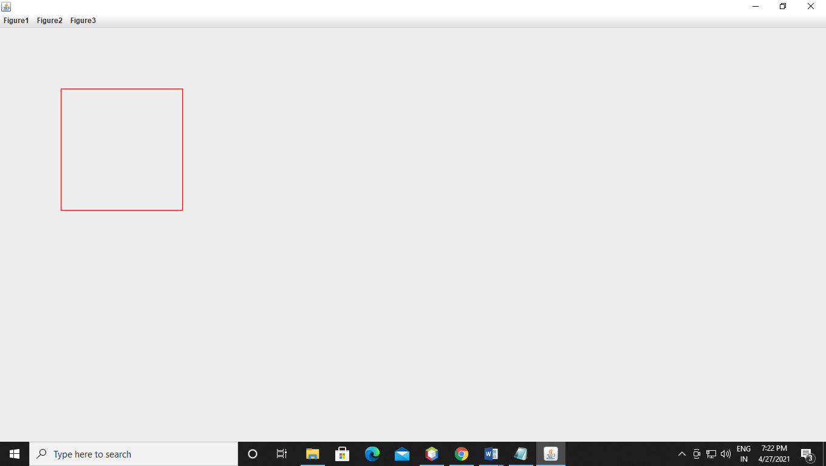

For Circle:-

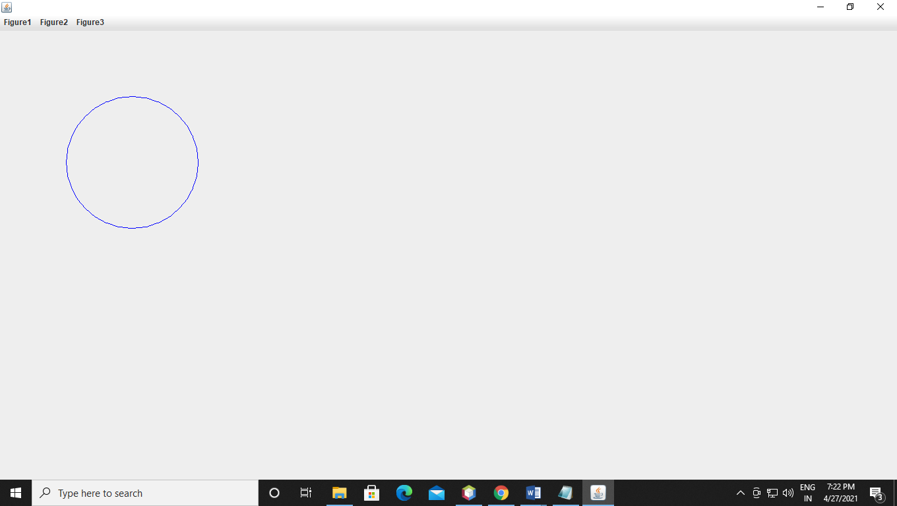

For Rectangle & Circle:-

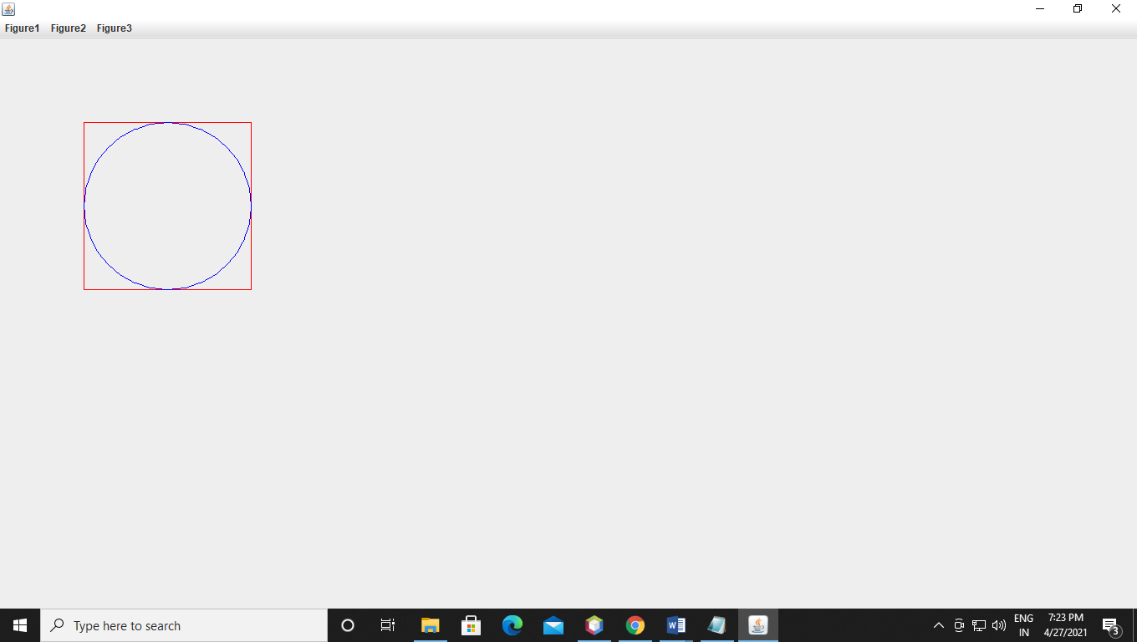

Q17 Write a Java Program to implement GUI and Select hobbies using Jcheckbox and display it.

Code:-

package JavaGuiLab;

/**

*

* @author prathmesha

*/

import java.awt.event.*;

import java.awt.*;

import javax.swing.*;

class solve extends JFrame implements ItemListener {

// frame

static JFrame f;

// label

static JLabel l, l1;

// checkbox

static JCheckBox c1, c2;

// main class

public static void main(String[] args)

{

// create a new frame

f = new JFrame("frame");

// create a object

solve s = new solve();

// set layout of frame

f.setLayout(new FlowLayout());

// create checkbox

c1 = new JCheckBox("Gaming", false);

c2 = new JCheckBox("coding", false);

// add ItemListener

c1.addItemListener(s);

c2.addItemListener(s);

// create labels

l = new JLabel("Gaming Not Selected");

l1 = new JLabel("Gaming Not Selected");

// set color of text

l.setForeground(Color.green);

l1.setForeground(Color.cyan);

// create a new panel

JPanel p = new JPanel();

// add checkbox to panel

p.add(c1);

p.add(c2);

p.add(l);

p.add(l1);

// add panel to frame

f.add(p);

// set the size of frame

f.setSize(600, 300);

f.show();

}

public void itemStateChanged(ItemEvent e)

{

// if the state of checkbox1 is changed

if (e.getSource() == c1) {

if (e.getStateChange() == 1)

l.setText("Gaming selected");

else

l.setText("Gaming not selected");

}

// if the state of checkbox2 is changed

else {

if (e.getStateChange() == 1)

l1.setText("Coding selected");

else

l1.setText("Coding not selected");

}

}

}

Output:-

Checkbox is not selected:-

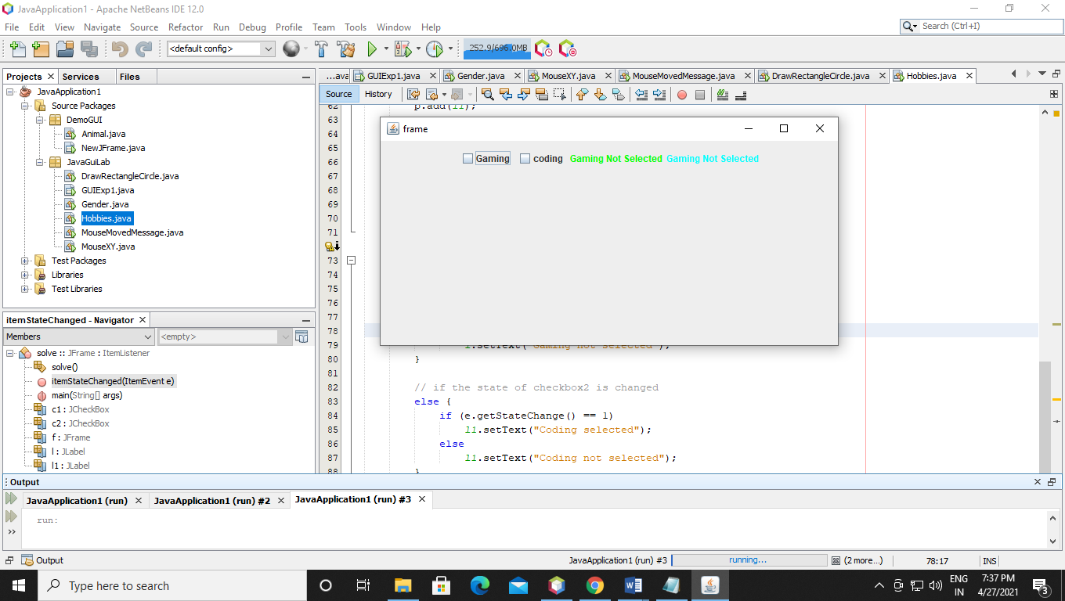

First checkbox is selected:-

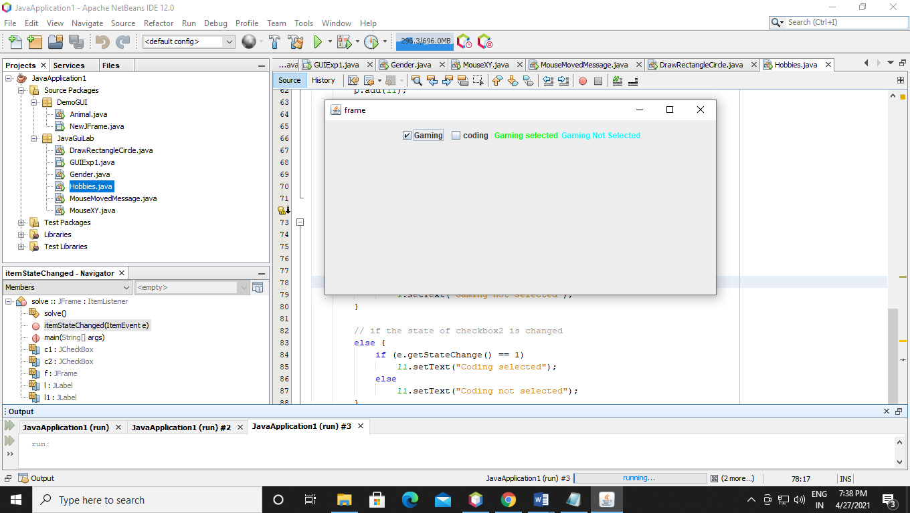

Second checkbox is selected:-

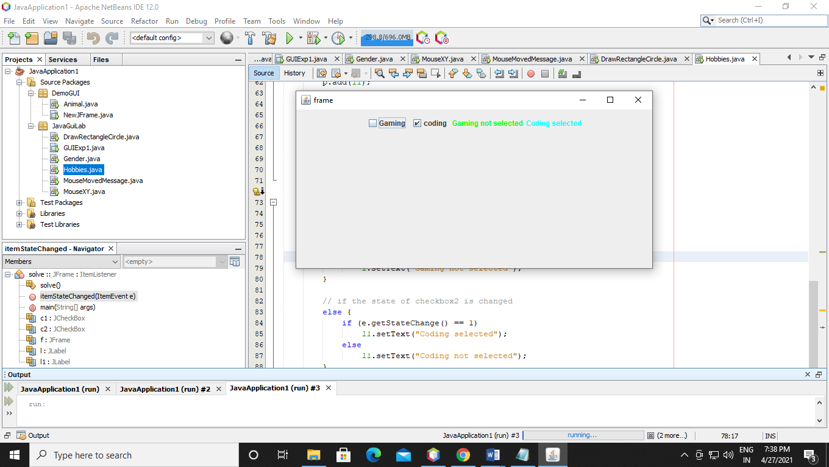

Both checkbox is selected:-

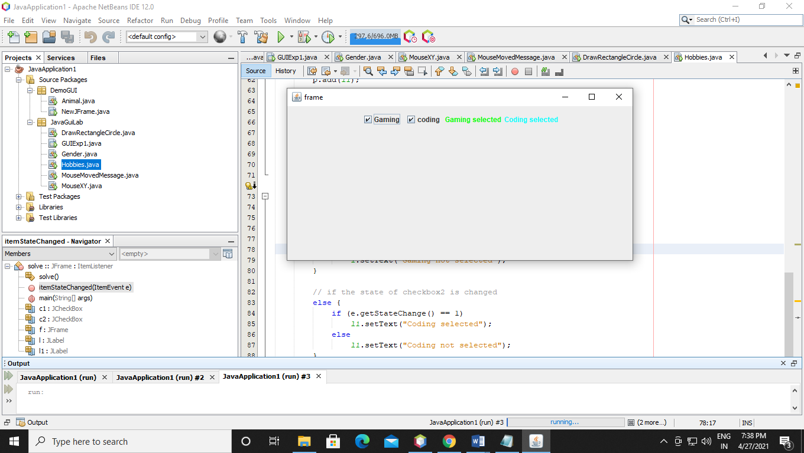

Q18. Write a java program to Create 3 sliders with colors set in each one of them and display the color changes inside a panel.

Code:-

package JavaGuiLab;

/**

*

* @author prathmesha

*/

import javax.swing.*;

import java.awt.event.*;

import java.awt.*;

public class Slider implements AdjustmentListener {

private static void createAndShowGUI() {

// make frame..

JFrame frame = new JFrame("JScrollBar");

frame.setDefaultCloseOperation(JFrame.EXIT_ON_CLOSE);

frame.setBounds(20,30,200,250);

frame.getContentPane().setLayout(null);

Slider app = new Slider();

app.sbar1 = new JScrollBar(java.awt.Adjustable.VERTICAL, 127, 1,0,255);

app.sbar1.setBounds(10,20, 10, 200);

app.sbar1.setBackground(Color.red);

app.sbar1.addAdjustmentListener(app);

frame.getContentPane().add(app.sbar1);

app.sbar2 = new JScrollBar(java.awt.Adjustable.VERTICAL, 127, 1,0,255);

app.sbar2.setBounds(30,20, 10, 200);

app.sbar2.setBackground(Color.green);

app.sbar2.addAdjustmentListener(app);

frame.getContentPane().add(app.sbar2);

app.sbar3 = new JScrollBar(java.awt.Adjustable.VERTICAL, 127, 1,0,255);

app.sbar3.setBounds(50,20, 10, 200);

app.sbar3.setBackground(Color.blue);

app.sbar3.addAdjustmentListener(app);

frame.getContentPane().add(app.sbar3);

app.panel = new JPanel();

app.panel.setBounds(80,20,50,200);

app.panel.setBackground(new Color(19, 19, 19));

frame.getContentPane().add(app.panel);

frame.setVisible(true);

}

public void adjustmentValueChanged(AdjustmentEvent e)

{

panel.setBackground(new Color(sbar1.getValue(),sbar2.getValue(), sbar3.getValue()));

}

public static void main(String[] args) {

// start off..

SwingUtilities.invokeLater(new Runnable() {

public void run() {

createAndShowGUI();

}

});

}

// application object fields

JScrollBar sbar1;

JScrollBar sbar2;

JScrollBar sbar3;

JPanel panel;

}

Output:-

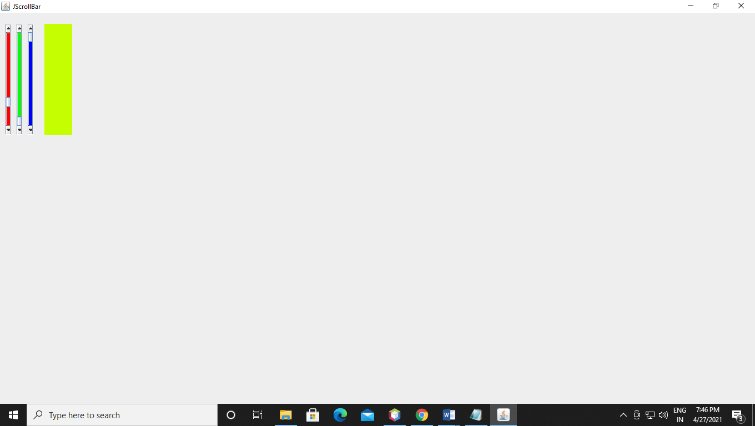

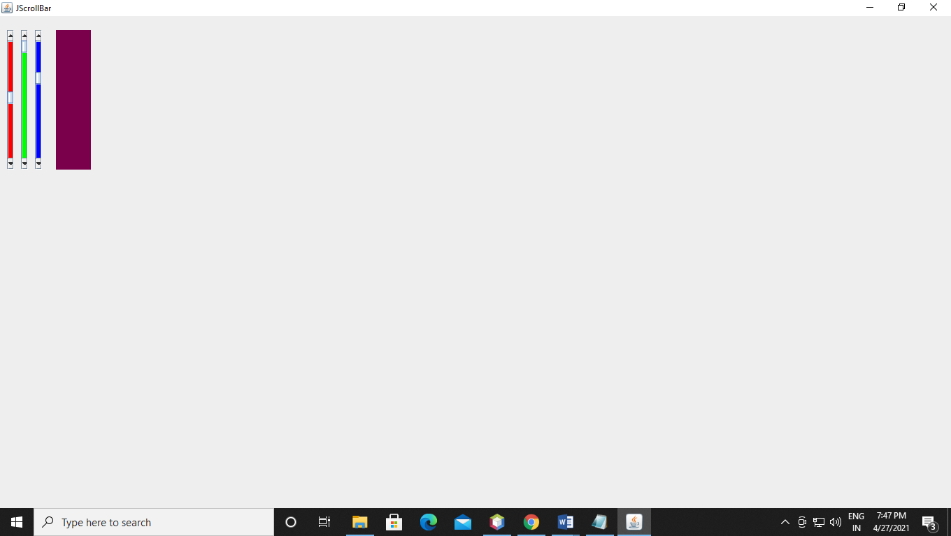

Q19. Create a random probability of a coin toss and display the outcome

Code:-

package JavaGuiLab;

/**

*

* @author prathmesha

*/

import java.util.Random;

class Demo {

public String chanceFunc() {

Random r = new Random();

int chance = r.nextInt(2);

if (chance == 1) {

return"tails";

} else {

return"heads";

}

}

}

public class Probabilty {

public static void main(String[] args) {

Demo t = new Demo();

int heads = 0;

int tails = 0;

int chances = 10;

for (int i = 1; i<= chances; i++) {

if (t.chanceFunc().equals("tails")) {

tails++;

} else {

heads++;

}

}

System.out.println("Chances = " + chances);

System.out.println("Heads: " + heads);

System.out.println("Tails: " + tails);

}

}

Output:-

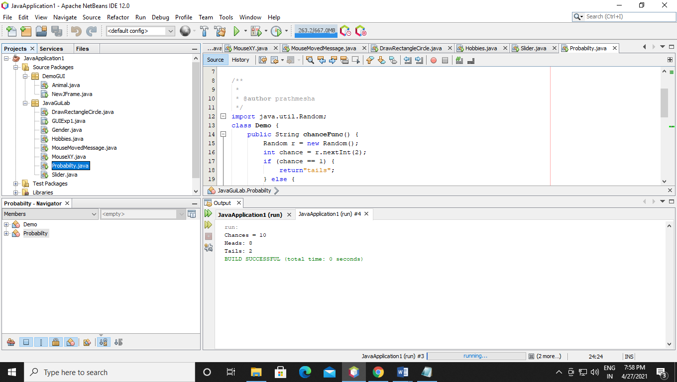

Q20. Write a java program to add two string using gui

Code:-

package JavaGuiLab;

/**

*

* @author prathmesha

*/

public class GUIString extends javax.swing.JFrame {

/**

* Creates new form GUIString

*/

public GUIString() {

initComponents();

}

/**

* This method is called from within the constructor to initialize the form.

* WARNING: Do NOT modify this code. The content of this method is always

* regenerated by the Form Editor.

*/

@SuppressWarnings("unchecked")

// <editor-fold defaultstate="collapsed" desc="Generated Code">

private void initComponents() {

jTextField1 = new javax.swing.JTextField();

jTextField2 = new javax.swing.JTextField();

jLabel1 = new javax.swing.JLabel();

jLabel2 = new javax.swing.JLabel();

jButton1 = new javax.swing.JButton();

jTextField3 = new javax.swing.JTextField();

setDefaultCloseOperation(javax.swing.WindowConstants.EXIT_ON_CLOSE);

jTextField1.addActionListener(new java.awt.event.ActionListener() {

public void actionPerformed(java.awt.event.ActionEvent evt) {

jTextField1ActionPerformed(evt);

}

});

jLabel1.setText("String A:-");

jLabel2.setText("String B:-");

jButton1.setText("Result");

jButton1.addActionListener(new java.awt.event.ActionListener() {

public void actionPerformed(java.awt.event.ActionEvent evt) {

jButton1ActionPerformed(evt);

}

});

jTextField3.setText("Result");

javax.swing.GroupLayout layout = new javax.swing.GroupLayout(getContentPane());

getContentPane().setLayout(layout);

layout.setHorizontalGroup(

layout.createParallelGroup(javax.swing.GroupLayout.Alignment.LEADING)

.addGroup(layout.createSequentialGroup()

.addGap(22, 22, 22)

.addGroup(layout.createParallelGroup(javax.swing.GroupLayout.Alignment.LEADING, false)

.addComponent(jLabel2, javax.swing.GroupLayout.DEFAULT_SIZE, javax.swing.GroupLayout.DEFAULT_SIZE, Short.MAX_VALUE)

.addComponent(jLabel1, javax.swing.GroupLayout.DEFAULT_SIZE, 47, Short.MAX_VALUE))

.addGap(31, 31, 31)

.addGroup(layout.createParallelGroup(javax.swing.GroupLayout.Alignment.LEADING)

.addComponent(jTextField2, javax.swing.GroupLayout.PREFERRED_SIZE, 85, javax.swing.GroupLayout.PREFERRED_SIZE)

.addComponent(jTextField1, javax.swing.GroupLayout.Alignment.TRAILING, javax.swing.GroupLayout.PREFERRED_SIZE, 85, javax.swing.GroupLayout.PREFERRED_SIZE))

.addGap(30, 30, 30)

.addComponent(jButton1)

.addPreferredGap(javax.swing.LayoutStyle.ComponentPlacement.RELATED)

.addComponent(jTextField3, javax.swing.GroupLayout.DEFAULT_SIZE, 106, Short.MAX_VALUE)

.addContainerGap())

);

layout.setVerticalGroup(

layout.createParallelGroup(javax.swing.GroupLayout.Alignment.LEADING)

.addGroup(layout.createSequentialGroup()

.addGroup(layout.createParallelGroup(javax.swing.GroupLayout.Alignment.LEADING)

.addGroup(layout.createSequentialGroup()

.addGap(42, 42, 42)

.addGroup(layout.createParallelGroup(javax.swing.GroupLayout.Alignment.BASELINE)

.addComponent(jTextField2, javax.swing.GroupLayout.PREFERRED_SIZE, 32, javax.swing.GroupLayout.PREFERRED_SIZE)

.addComponent(jLabel1, javax.swing.GroupLayout.PREFERRED_SIZE, 32, javax.swing.GroupLayout.PREFERRED_SIZE))

.addGap(18, 18, 18)

.addGroup(layout.createParallelGroup(javax.swing.GroupLayout.Alignment.BASELINE)

.addComponent(jTextField1, javax.swing.GroupLayout.PREFERRED_SIZE, 32, javax.swing.GroupLayout.PREFERRED_SIZE)

.addComponent(jLabel2, javax.swing.GroupLayout.PREFERRED_SIZE, 32, javax.swing.GroupLayout.PREFERRED_SIZE)))

.addGroup(layout.createSequentialGroup()

.addGap(70, 70, 70)

.addGroup(layout.createParallelGroup(javax.swing.GroupLayout.Alignment.BASELINE)

.addComponent(jButton1)

.addComponent(jTextField3, javax.swing.GroupLayout.PREFERRED_SIZE, 41, javax.swing.GroupLayout.PREFERRED_SIZE))))

.addContainerGap(176, Short.MAX_VALUE))

);

pack();

}// </editor-fold>

private void jTextField1ActionPerformed(java.awt.event.ActionEvent evt) {

// TODO add your handling code here:

}

private void jButton1ActionPerformed(java.awt.event.ActionEvent evt) {

// TODO add your handling code here:

String A, B, result;

A = jTextField2.getText();

B = jTextField1.getText();

result = A + B;

jTextField3.setText(String.valueOf(result));

}

/**

* @param args the command line arguments

*/

public static void main(String args[]) {

/* Set the Nimbus look and feel */

//<editor-fold defaultstate="collapsed" desc=" Look and feel setting code (optional) ">

/* If Nimbus (introduced in Java SE 6) is not available, stay with the default look and feel.

* For details see http://download.oracle.com/javase/tutorial/uiswing/lookandfeel/plaf.html

*/

try {

for (javax.swing.UIManager.LookAndFeelInfo info : javax.swing.UIManager.getInstalledLookAndFeels()) {

if ("Nimbus".equals(info.getName())) {

javax.swing.UIManager.setLookAndFeel(info.getClassName());

break;

}

}

} catch (ClassNotFoundException ex) {

java.util.logging.Logger.getLogger(GUIString.class.getName()).log(java.util.logging.Level.SEVERE, null, ex);

} catch (InstantiationException ex) {

java.util.logging.Logger.getLogger(GUIString.class.getName()).log(java.util.logging.Level.SEVERE, null, ex);

} catch (IllegalAccessException ex) {

java.util.logging.Logger.getLogger(GUIString.class.getName()).log(java.util.logging.Level.SEVERE, null, ex);

} catch (javax.swing.UnsupportedLookAndFeelException ex) {

java.util.logging.Logger.getLogger(GUIString.class.getName()).log(java.util.logging.Level.SEVERE, null, ex);

}

//</editor-fold>

/* Create and display the form */

java.awt.EventQueue.invokeLater(new Runnable() {

public void run() {

new GUIString().setVisible(true);

}

});

}

// Variables declaration - do not modify

private javax.swing.JButton jButton1;

private javax.swing.JLabel jLabel1;

private javax.swing.JLabel jLabel2;

private javax.swing.JTextField jTextField1;

private javax.swing.JTextField jTextField2;

private javax.swing.JTextField jTextField3;

// End of variables declaration

}

Output:-

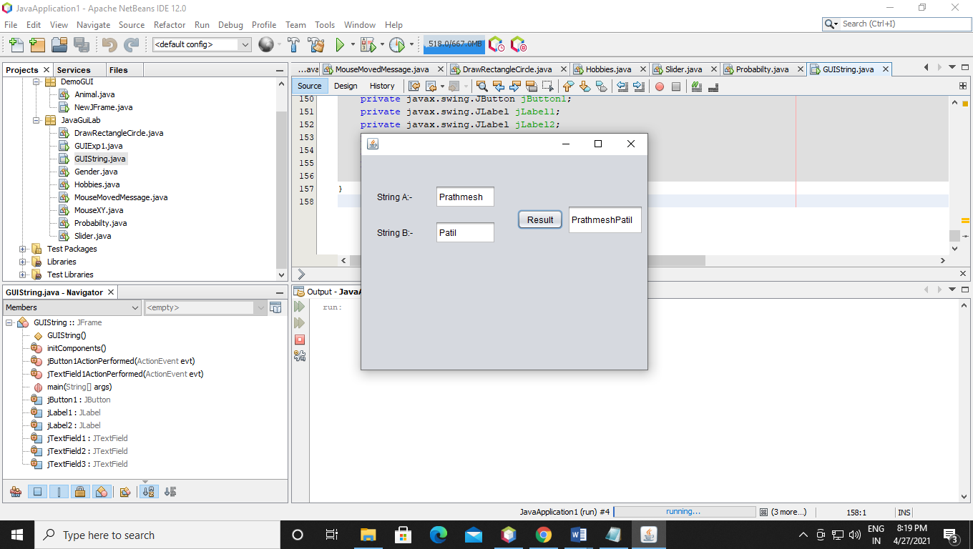

Q21 Write java program to create combobox

Code:-

package JavaGuiLab;

/**

*

* @author prathmesha

*/

public class ComboBox extends javax.swing.JFrame {

/**

* Creates new form ComboBox

*/

public ComboBox() {

initComponents();

}

/**

* This method is called from within the constructor to initialize the form.

* WARNING: Do NOT modify this code. The content of this method is always

* regenerated by the Form Editor.

*/

@SuppressWarnings("unchecked")

// <editor-fold defaultstate="collapsed" desc="Generated Code">

private void initComponents() {

jComboBox1 = new javax.swing.JComboBox<>();

setDefaultCloseOperation(javax.swing.WindowConstants.EXIT_ON_CLOSE);

jComboBox1.setModel(new javax.swing.DefaultComboBoxModel<>(new String[] { "C", "C++", "JAVA", "PYTHON", "PHP" }));

jComboBox1.addActionListener(new java.awt.event.ActionListener() {

public void actionPerformed(java.awt.event.ActionEvent evt) {

jComboBox1ActionPerformed(evt);

}

});

javax.swing.GroupLayout layout = new javax.swing.GroupLayout(getContentPane());

getContentPane().setLayout(layout);

layout.setHorizontalGroup(

layout.createParallelGroup(javax.swing.GroupLayout.Alignment.LEADING)

.addGroup(layout.createSequentialGroup()

.addGap(140, 140, 140)

.addComponent(jComboBox1, javax.swing.GroupLayout.PREFERRED_SIZE, 88, javax.swing.GroupLayout.PREFERRED_SIZE)

.addContainerGap(172, Short.MAX_VALUE))

);

layout.setVerticalGroup(

layout.createParallelGroup(javax.swing.GroupLayout.Alignment.LEADING)

.addGroup(layout.createSequentialGroup()

.addGap(70, 70, 70)

.addComponent(jComboBox1, javax.swing.GroupLayout.PREFERRED_SIZE, 35, javax.swing.GroupLayout.PREFERRED_SIZE)

.addContainerGap(195, Short.MAX_VALUE))

);

pack();

}// </editor-fold>

private void jComboBox1ActionPerformed(java.awt.event.ActionEvent evt) {

// TODO add your handling code here:

}

/**

* @param args the command line arguments

*/

public static void main(String args[]) {

/* Set the Nimbus look and feel */

//<editor-fold defaultstate="collapsed" desc=" Look and feel setting code (optional) ">

/* If Nimbus (introduced in Java SE 6) is not available, stay with the default look and feel.

* For details see http://download.oracle.com/javase/tutorial/uiswing/lookandfeel/plaf.html

*/

try {

for (javax.swing.UIManager.LookAndFeelInfo info : javax.swing.UIManager.getInstalledLookAndFeels()) {

if ("Nimbus".equals(info.getName())) {

javax.swing.UIManager.setLookAndFeel(info.getClassName());

break;

}

}

} catch (ClassNotFoundException ex) {

java.util.logging.Logger.getLogger(ComboBox.class.getName()).log(java.util.logging.Level.SEVERE, null, ex);

} catch (InstantiationException ex) {

java.util.logging.Logger.getLogger(ComboBox.class.getName()).log(java.util.logging.Level.SEVERE, null, ex);

} catch (IllegalAccessException ex) {

java.util.logging.Logger.getLogger(ComboBox.class.getName()).log(java.util.logging.Level.SEVERE, null, ex);

} catch (javax.swing.UnsupportedLookAndFeelException ex) {

java.util.logging.Logger.getLogger(ComboBox.class.getName()).log(java.util.logging.Level.SEVERE, null, ex);

}

//</editor-fold>

/* Create and display the form */

java.awt.EventQueue.invokeLater(new Runnable() {

public void run() {

new ComboBox().setVisible(true);

}

});

}

// Variables declaration - do not modify

private javax.swing.JComboBox<String> jComboBox1;

// End of variables declaration

}

Output:-

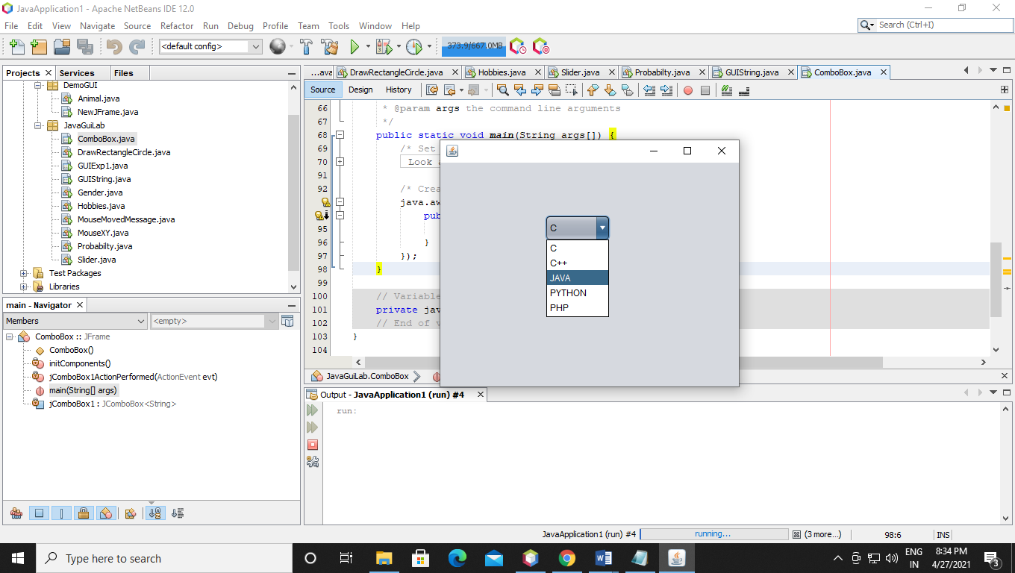

Q22 Write java program to create menu

Code:-

package JavaGuiLab;

/**

*

* @author prathmesha

*/

public class Menu extends javax.swing.JFrame {

/**

* Creates new form Menu

*/

public Menu() {

initComponents();

}

/**

* This method is called from within the constructor to initialize the form.

* WARNING: Do NOT modify this code. The content of this method is always

* regenerated by the Form Editor.

*/

@SuppressWarnings("unchecked")

// <editor-fold defaultstate="collapsed" desc="Generated Code">

private void initComponents() {

jMenuBar1 = new javax.swing.JMenuBar();

jMenu1 = new javax.swing.JMenu();

jMenu3 = new javax.swing.JMenu();

jMenu4 = new javax.swing.JMenu();

jMenu5 = new javax.swing.JMenu();

jMenu8 = new javax.swing.JMenu();

jMenu13 = new javax.swing.JMenu();

jMenu9 = new javax.swing.JMenu();

jMenu14 = new javax.swing.JMenu();

jMenu10 = new javax.swing.JMenu();

jMenu11 = new javax.swing.JMenu();

jMenu6 = new javax.swing.JMenu();

jMenu7 = new javax.swing.JMenu();

jMenu12 = new javax.swing.JMenu();

setDefaultCloseOperation(javax.swing.WindowConstants.EXIT_ON_CLOSE);

jMenu1.setText("File");

jMenu3.setText("C++");

jMenu1.add(jMenu3);

jMenu4.setText("JAVA");

jMenu1.add(jMenu4);

jMenu5.setText("PYTHON");

jMenu8.setText("UNIX");

jMenu13.setText("DAA");

jMenu8.add(jMenu13);

jMenu5.add(jMenu8);

jMenu9.setText("CYBER");

jMenu14.setText("DS");

jMenu9.add(jMenu14);

jMenu5.add(jMenu9);

jMenu10.setText("PHP");

jMenu5.add(jMenu10);

jMenu11.setText("BI");

jMenu5.add(jMenu11);

jMenu1.add(jMenu5);

jMenu6.setText("MAVEN");

jMenu1.add(jMenu6);

jMenu7.setText("SWIFT");

jMenu1.add(jMenu7);

jMenu12.setText("UI/UX");

jMenu1.add(jMenu12);

jMenuBar1.add(jMenu1);

setJMenuBar(jMenuBar1);

javax.swing.GroupLayout layout = new javax.swing.GroupLayout(getContentPane());

getContentPane().setLayout(layout);

layout.setHorizontalGroup(

layout.createParallelGroup(javax.swing.GroupLayout.Alignment.LEADING)

.addGap(0, 400, Short.MAX_VALUE)

);

layout.setVerticalGroup(

layout.createParallelGroup(javax.swing.GroupLayout.Alignment.LEADING)

.addGap(0, 279, Short.MAX_VALUE)

);

pack();

}// </editor-fold>

/**

* @param args the command line arguments

*/

public static void main(String args[]) {

/* Set the Nimbus look and feel */

//<editor-fold defaultstate="collapsed" desc=" Look and feel setting code (optional) ">

/* If Nimbus (introduced in Java SE 6) is not available, stay with the default look and feel.

* For details see http://download.oracle.com/javase/tutorial/uiswing/lookandfeel/plaf.html

*/

try {

for (javax.swing.UIManager.LookAndFeelInfo info : javax.swing.UIManager.getInstalledLookAndFeels()) {

if ("Nimbus".equals(info.getName())) {

javax.swing.UIManager.setLookAndFeel(info.getClassName());

break;

}

}

} catch (ClassNotFoundException ex) {

java.util.logging.Logger.getLogger(Menu.class.getName()).log(java.util.logging.Level.SEVERE, null, ex);

} catch (InstantiationException ex) {

java.util.logging.Logger.getLogger(Menu.class.getName()).log(java.util.logging.Level.SEVERE, null, ex);

} catch (IllegalAccessException ex) {

java.util.logging.Logger.getLogger(Menu.class.getName()).log(java.util.logging.Level.SEVERE, null, ex);

} catch (javax.swing.UnsupportedLookAndFeelException ex) {

java.util.logging.Logger.getLogger(Menu.class.getName()).log(java.util.logging.Level.SEVERE, null, ex);

}

//</editor-fold>

/* Create and display the form */

java.awt.EventQueue.invokeLater(new Runnable() {

public void run() {

new Menu().setVisible(true);

}

});

}

// Variables declaration - do not modify

private javax.swing.JMenu jMenu1;

private javax.swing.JMenu jMenu10;

private javax.swing.JMenu jMenu11;

private javax.swing.JMenu jMenu12;

private javax.swing.JMenu jMenu13;

private javax.swing.JMenu jMenu14;

private javax.swing.JMenu jMenu3;

private javax.swing.JMenu jMenu4;

private javax.swing.JMenu jMenu5;

private javax.swing.JMenu jMenu6;

private javax.swing.JMenu jMenu7;

private javax.swing.JMenu jMenu8;

private javax.swing.JMenu jMenu9;

private javax.swing.JMenuBar jMenuBar1;

// End of variables declaration

}

Output:-

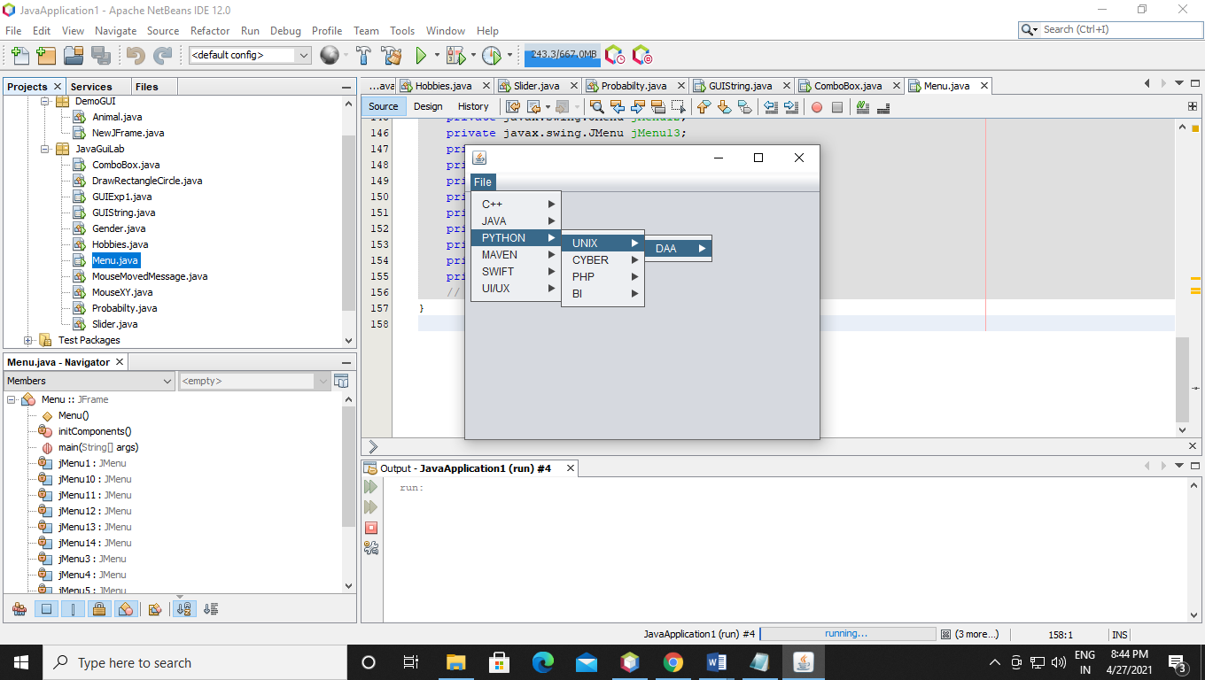

Q23 Write java program to create radio button.

Code:-

package JavaGuiLab;

/**

*

* @author prathmesha

*/

public class RadioButton extends javax.swing.JFrame {

/**

* Creates new form RadioButton

*/

public RadioButton() {

initComponents();

}

/**

* This method is called from within the constructor to initialize the form.

* WARNING: Do NOT modify this code. The content of this method is always

* regenerated by the Form Editor.

*/

@SuppressWarnings("unchecked")

// <editor-fold defaultstate="collapsed" desc="Generated Code">

private void initComponents() {

jRadioButton1 = new javax.swing.JRadioButton();

jRadioButton2 = new javax.swing.JRadioButton();

jRadioButton3 = new javax.swing.JRadioButton();

jRadioButton4 = new javax.swing.JRadioButton();

setDefaultCloseOperation(javax.swing.WindowConstants.EXIT_ON_CLOSE);

jRadioButton1.setText("C++");

jRadioButton1.addActionListener(new java.awt.event.ActionListener() {

public void actionPerformed(java.awt.event.ActionEvent evt) {

jRadioButton1ActionPerformed(evt);

}

});

jRadioButton2.setText("JAVA");

jRadioButton2.addActionListener(new java.awt.event.ActionListener() {

public void actionPerformed(java.awt.event.ActionEvent evt) {

jRadioButton2ActionPerformed(evt);

}

});

jRadioButton3.setText("PYTHON");

jRadioButton4.setText("PHP");

javax.swing.GroupLayout layout = new javax.swing.GroupLayout(getContentPane());

getContentPane().setLayout(layout);

layout.setHorizontalGroup(

layout.createParallelGroup(javax.swing.GroupLayout.Alignment.LEADING)

.addGroup(layout.createSequentialGroup()

.addGap(106, 106, 106)

.addGroup(layout.createParallelGroup(javax.swing.GroupLayout.Alignment.LEADING)

.addComponent(jRadioButton4)

.addComponent(jRadioButton3)

.addComponent(jRadioButton2)

.addComponent(jRadioButton1))

.addContainerGap(229, Short.MAX_VALUE))

);

layout.setVerticalGroup(

layout.createParallelGroup(javax.swing.GroupLayout.Alignment.LEADING)

.addGroup(layout.createSequentialGroup()

.addGap(40, 40, 40)

.addComponent(jRadioButton1)

.addPreferredGap(javax.swing.LayoutStyle.ComponentPlacement.UNRELATED)

.addComponent(jRadioButton2)

.addPreferredGap(javax.swing.LayoutStyle.ComponentPlacement.UNRELATED)

.addComponent(jRadioButton3)

.addPreferredGap(javax.swing.LayoutStyle.ComponentPlacement.UNRELATED)

.addComponent(jRadioButton4)

.addContainerGap(159, Short.MAX_VALUE))

);

pack();

}// </editor-fold>

private void jRadioButton1ActionPerformed(java.awt.event.ActionEvent evt) {

// TODO add your handling code here:

}

private void jRadioButton2ActionPerformed(java.awt.event.ActionEvent evt) {

// TODO add your handling code here:

}

/**

* @param args the command line arguments

*/

public static void main(String args[]) {

/* Set the Nimbus look and feel */

//<editor-fold defaultstate="collapsed" desc=" Look and feel setting code (optional) ">

/* If Nimbus (introduced in Java SE 6) is not available, stay with the default look and feel.

* For details see http://download.oracle.com/javase/tutorial/uiswing/lookandfeel/plaf.html

*/

try {

for (javax.swing.UIManager.LookAndFeelInfo info : javax.swing.UIManager.getInstalledLookAndFeels()) {

if ("Nimbus".equals(info.getName())) {

javax.swing.UIManager.setLookAndFeel(info.getClassName());

break;

}

}

} catch (ClassNotFoundException ex) {

java.util.logging.Logger.getLogger(RadioButton.class.getName()).log(java.util.logging.Level.SEVERE, null, ex);

} catch (InstantiationException ex) {

java.util.logging.Logger.getLogger(RadioButton.class.getName()).log(java.util.logging.Level.SEVERE, null, ex);

} catch (IllegalAccessException ex) {

java.util.logging.Logger.getLogger(RadioButton.class.getName()).log(java.util.logging.Level.SEVERE, null, ex);

} catch (javax.swing.UnsupportedLookAndFeelException ex) {

java.util.logging.Logger.getLogger(RadioButton.class.getName()).log(java.util.logging.Level.SEVERE, null, ex);

}

//</editor-fold>

/* Create and display the form */

java.awt.EventQueue.invokeLater(new Runnable() {

public void run() {

new RadioButton().setVisible(true);

}

});

}

// Variables declaration - do not modify

private javax.swing.JRadioButton jRadioButton1;

private javax.swing.JRadioButton jRadioButton2;

private javax.swing.JRadioButton jRadioButton3;

private javax.swing.JRadioButton jRadioButton4;

// End of variables declaration

}

Output:-

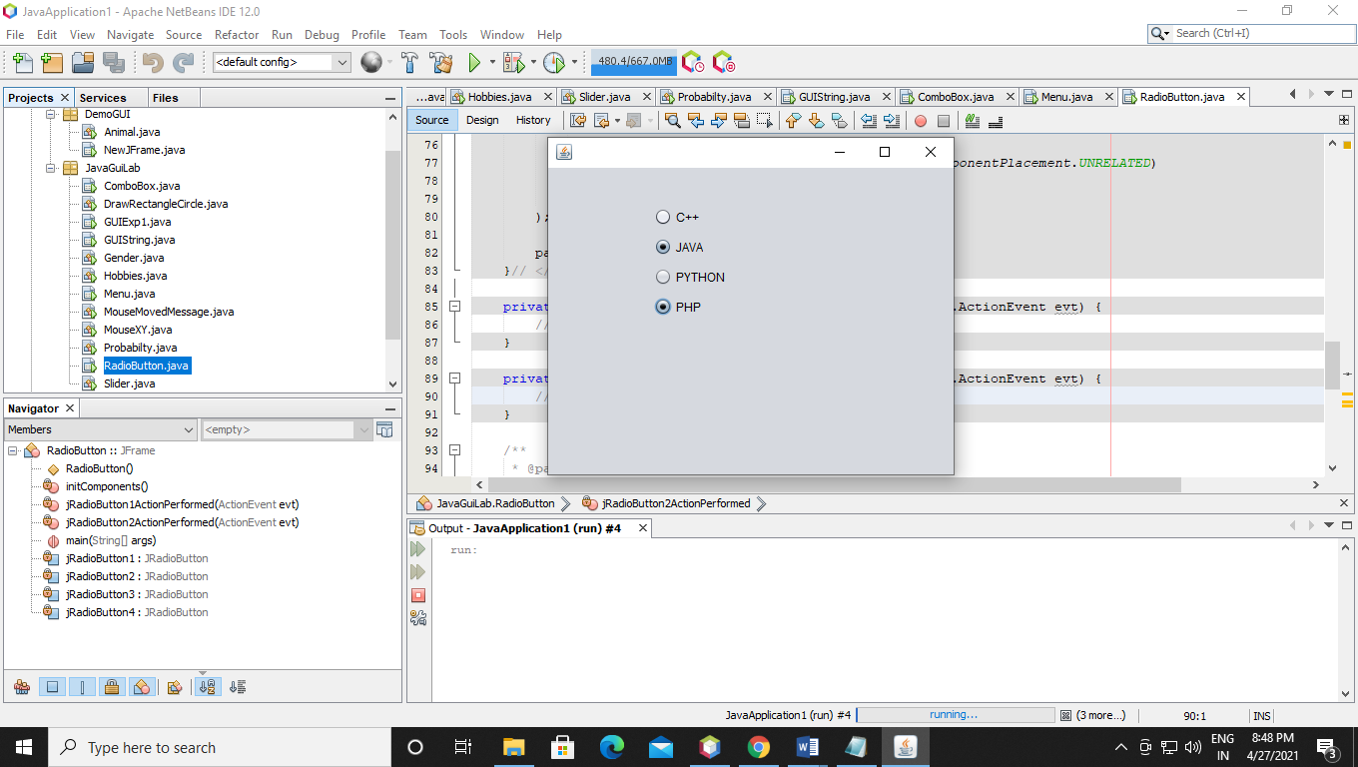

Q24 Write java program to run threads

Code:-

package JavaGuiLab;

/**

*

* @author prathmesha

*/

import java.awt.BorderLayout;

import java.awt.FlowLayout;

import javax.swing.JButton;

import javax.swing.JDialog;

import javax.swing.JPanel;

import javax.swing.border.EmptyBorder;

import java.awt.event.ActionListener;

import java.awt.event.ActionEvent;

import javax.swing.JLabel;

import java.awt.Font;

class MyThread extends Thread

{

public void run()

{

int i ;

System.out.println("Thread One started.");

for(i = 0; i <=100 ; i++) {

System.out.println("Thread " + i);

if(i==30) {

try {

this.sleep(4000);

i++;

} catch (InterruptedException e) {

// TODO Auto-generated catch block

e.printStackTrace();

}

}

}

System.out.println("Thread one finished.");

}

}

//second thread

class AnotherThread extends Thread

{

public void run()

{

int i ;

System.out.println("Thread Two started.");

for(i = 101; i <=200 ; i++) {

System.out.println("Another Thread " + i);

}

System.out.println("Thread two finished.");

}

}

class RunThread extends JDialog {

private final JPanel contentPanel = new JPanel();

/**

* Launch the application.

*/

public static void main(String[] args) {

try {

RunThread dialog = new RunThread();

dialog.setDefaultCloseOperation(JDialog.DISPOSE_ON_CLOSE);

dialog.setVisible(true);

} catch (Exception e) {

e.printStackTrace();

}

}

/**

* Create the dialog.

*/

public RunThread() {

setBounds(100, 100, 450, 300);

getContentPane().setLayout(new BorderLayout());

contentPanel.setBorder(new EmptyBorder(5, 5, 5, 5));

getContentPane().add(contentPanel, BorderLayout.CENTER);

contentPanel.setLayout(null);

JButton btnNewButton = new JButton("Run Thread");

btnNewButton.addActionListener(new ActionListener() {

public void actionPerformed(ActionEvent e) {

MyThread t1 = new MyThread();

t1.start();

System.out.println("Priority of thread t1 " + t1.getPriority());

AnotherThread t2 = new AnotherThread();

t2.start();

System.out.println("Priority of thread t2 " + t2.getPriority());

}

});

btnNewButton.setBounds(73, 45, 128, 31);

contentPanel.add(btnNewButton);

{

JPanel buttonPane = new JPanel();

buttonPane.setLayout(new FlowLayout(FlowLayout.RIGHT));

getContentPane().add(buttonPane, BorderLayout.SOUTH);

{

JButton okButton = new JButton("OK");

okButton.setActionCommand("OK");

buttonPane.add(okButton);

getRootPane().setDefaultButton(okButton);

}

{

JButton cancelButton = new JButton("Cancel");

cancelButton.setActionCommand("Cancel");

buttonPane.add(cancelButton);

}

}

}

}

Output:-

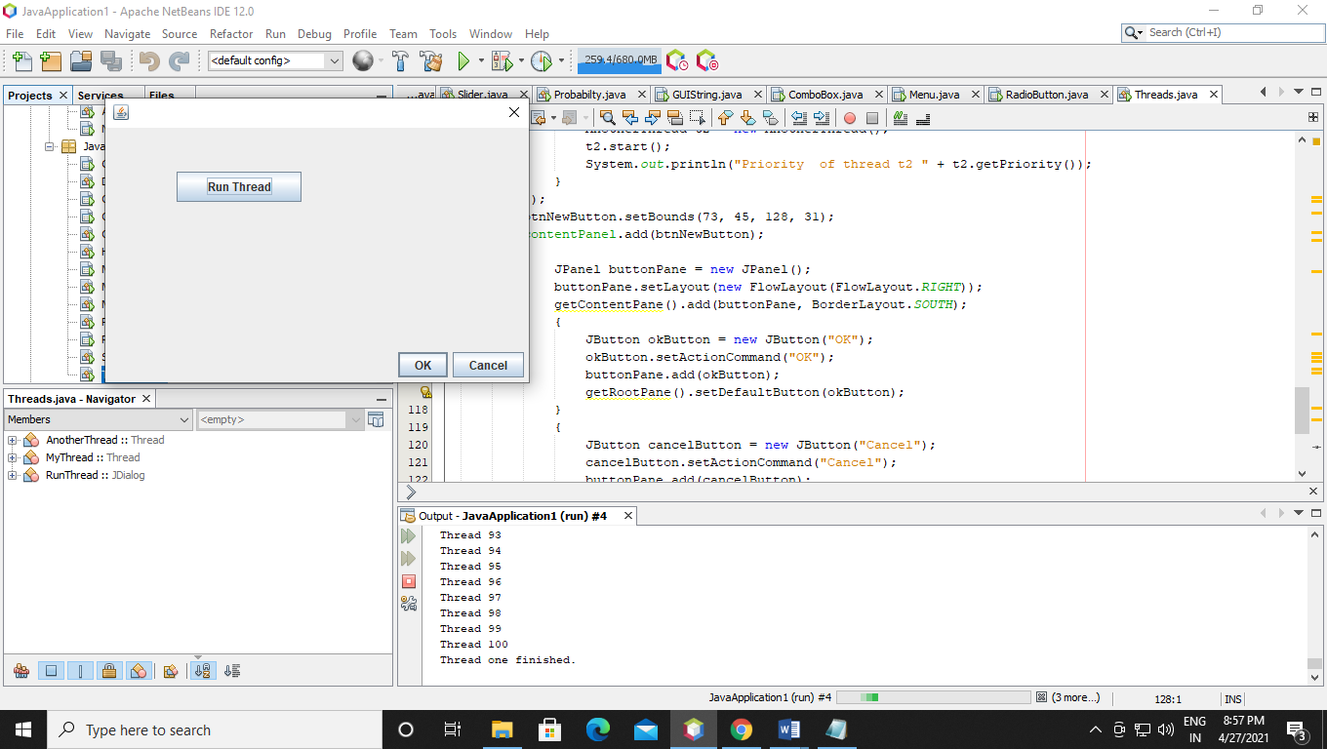

Q25 Write java program to demo date from gui

Code:-

package JavaGuiLab;

/**

*

* @author prathmesha

*/

import java.awt.BorderLayout;

import java.awt.FlowLayout;

import javax.swing.JButton;

import javax.swing.JDialog;

import javax.swing.JPanel;

import javax.swing.border.EmptyBorder;

import javax.swing.JLabel;

import javax.swing.JTextField;

import java.awt.Font;

import java.util.Date;

import java.awt.event.ActionListener;

import java.text.SimpleDateFormat;

import java.awt.event.ActionEvent;

public class DateGUI extends JDialog {

private final JPanel contentPanel = new JPanel();

private JTextField textField;

Date dt;

Date dob;

private JTextField textField_1;

/**

* Launch the application.

*/

public static void main(String[] args) {

try {

DateGUI dialog = new DateGUI();

dialog.setDefaultCloseOperation(JDialog.DISPOSE_ON_CLOSE);

dialog.setVisible(true);

} catch (Exception e) {

e.printStackTrace();

}

}

/**

* Create the dialog.

*/

public DateGUI() {

dt = new Date();

setBounds(100, 100, 528, 382);

getContentPane().setLayout(new BorderLayout());

contentPanel.setBorder(new EmptyBorder(5, 5, 5, 5));

getContentPane().add(contentPanel, BorderLayout.CENTER);

contentPanel.setLayout(null);

textField = new JTextField();

textField.setFont(new Font("Tahoma", Font.BOLD, 15));

textField.setBounds(107, 53, 314, 38);

contentPanel.add(textField);

textField.setColumns(10);

textField.setText(dt.toString());

JButton btnNewButton = new JButton("DD/MM/YYYY");

btnNewButton.addActionListener(new ActionListener() {

public void actionPerformed(ActionEvent e) {

SimpleDateFormat ft = new SimpleDateFormat("dd/MM/yyyy");

String st = ft.format(dt);

textField.setText(st);

}

});

btnNewButton.setBounds(40, 117, 111, 29);

contentPanel.add(btnNewButton);

{

JButton btnNewButton_1 = new JButton("DOB");

btnNewButton_1.addActionListener(new ActionListener() {

public void actionPerformed(ActionEvent e) {

SimpleDateFormat ft = new SimpleDateFormat("dd/MM/yyyy");

dob = new Date(101,11,27);

String st = ft.format(dob);

textField.setText(st);

}

});

btnNewButton_1.setBounds(281, 121, 111, 25);

contentPanel.add(btnNewButton_1);

}

{

JButton btnNewButton_2 = new JButton("Compare Date");

btnNewButton_2.addActionListener(new ActionListener() {

public void actionPerformed(ActionEvent e) {

/*

boolean flag = dt.after(dob);

textField_1.setText(Boolean.toString(flag));*/

Date currentDate = new Date();

Date DOB1 = new Date(70,8,17);

System.out.println("Current Date");

System.out.println("Current Date " + currentDate.getDate());

System.out.println("Current Month " + currentDate.getMonth());

System.out.println("Current Year " + currentDate.getYear());

System.out.println("Date Of Birth");

System.out.println("Date for DOB " + DOB1.getDate());

System.out.println("Month for DOB " + DOB1.getMonth());

System.out.println("Year for DOB " + DOB1.getYear());

}

});

btnNewButton_2.setBounds(40, 207, 127, 29);

contentPanel.add(btnNewButton_2);

}

{

textField_1 = new JTextField();

textField_1.setBounds(281, 212, 121, 38);

contentPanel.add(textField_1);

textField_1.setColumns(10);

}

{

JPanel buttonPane = new JPanel();

buttonPane.setLayout(new FlowLayout(FlowLayout.RIGHT));

getContentPane().add(buttonPane, BorderLayout.SOUTH);

{

JButton okButton = new JButton("OK");

okButton.setActionCommand("OK");

buttonPane.add(okButton);

getRootPane().setDefaultButton(okButton);

}

{

JButton cancelButton = new JButton("Cancel");

cancelButton.setActionCommand("Cancel");

buttonPane.add(cancelButton);

}

}

}

}

Output:-

Checking Current Date:-

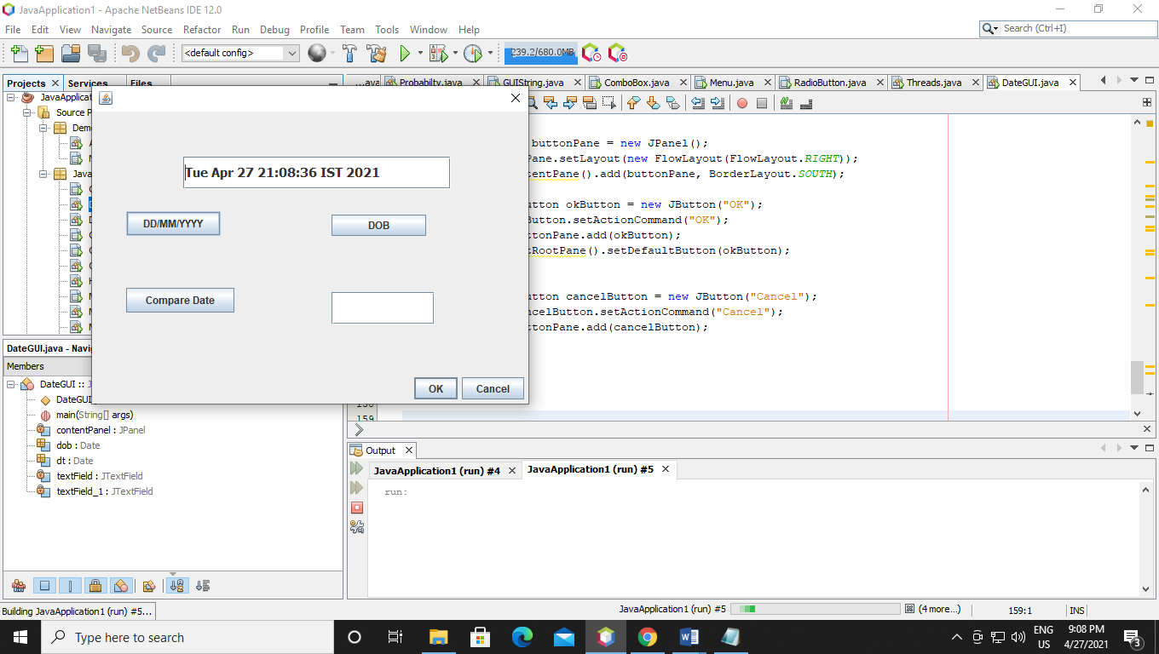

Checking todays date:-

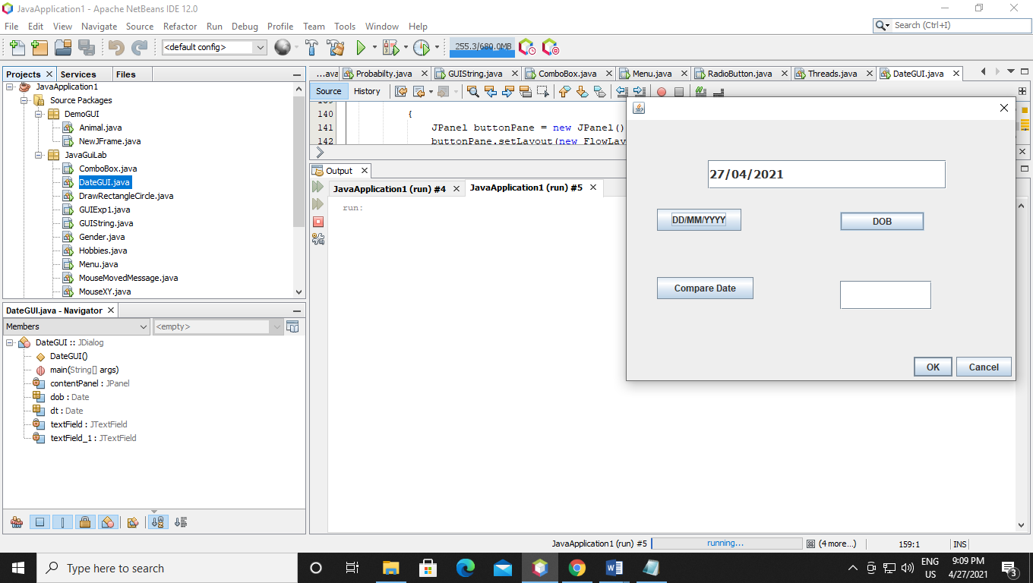

Checking DOB:-

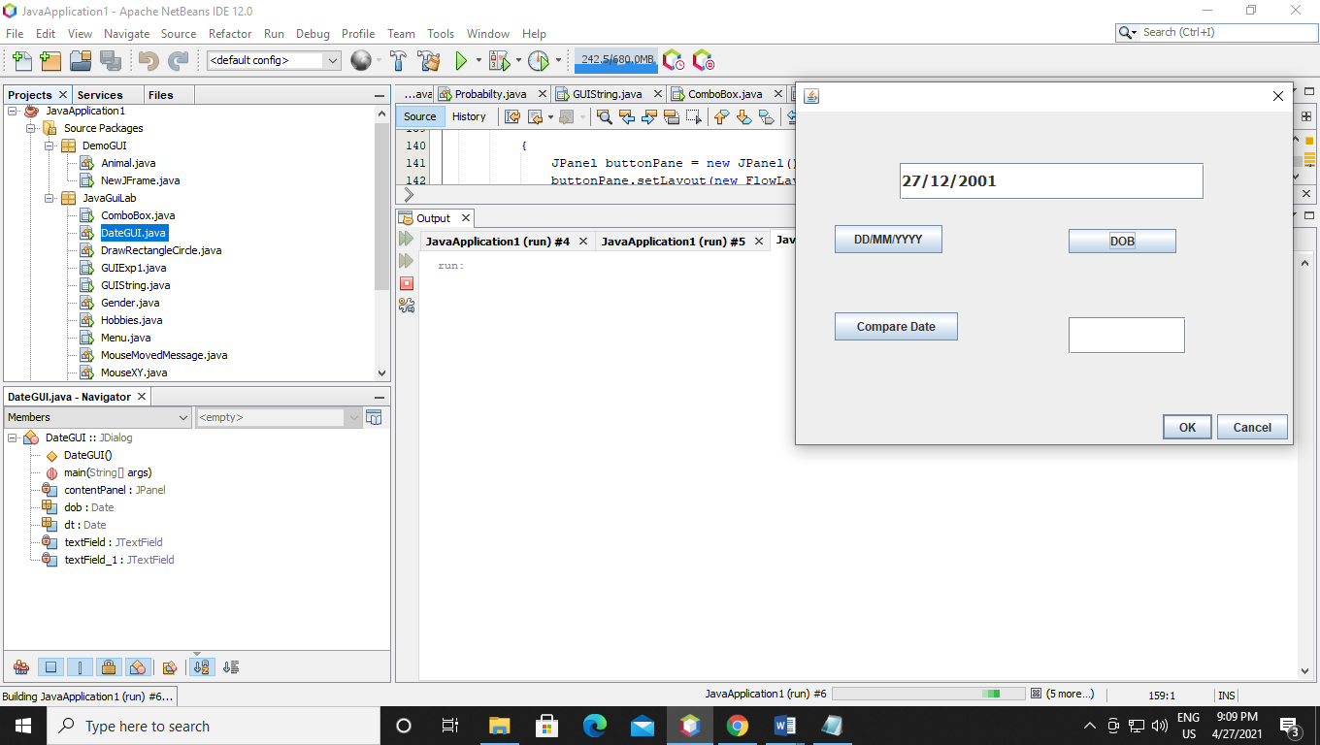

Comparing Current & DOB:-

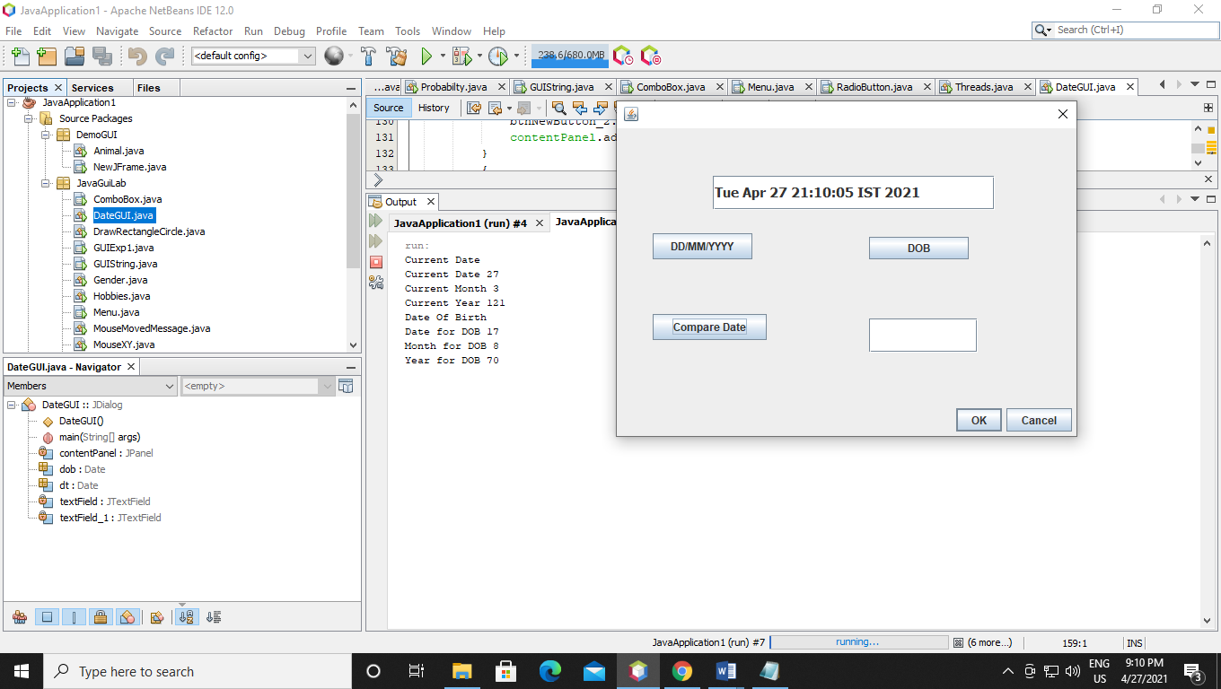

Q26 Write java program to display server and client

Code:-

Server:-

package JavaGuiLab;

/**

*

* @author prathmesha

*/

import java.io.IOException;

import java.io.PrintStream;

import java.net.ServerSocket;

import java.net.Socket;

import java.util.Scanner;

public class Server {

public static void main(String args []) throws IOException {

ServerSocket ss = new ServerSocket(1342);

Socket s = ss.accept();

Scanner sc = new Scanner(s.getInputStream());

int number = sc.nextInt();

int temp = number+number;

PrintStream p = new PrintStream(s.getOutputStream());

p.println(temp);

}

}

Client:-

import java.io.IOException;

import java.io.PrintStream;

import java.net.Socket;

import java.net.UnknownHostException;

import java.util.Scanner;

public class Client {

public static void main(String args[]) throws UnknownHostException, IOException {

Scanner sc = new Scanner(System.in);

Socket s = new Socket("localhost" , 1342);

Scanner sc1 = new Scanner(s.getInputStream());

System.out.println("Enter any number.");

int number = sc.nextInt();

PrintStream p = new PrintStream(s.getOutputStream());

p.println(number);

int temp = sc1.nextInt();

System.out.println(temp);

}

}

Output:-

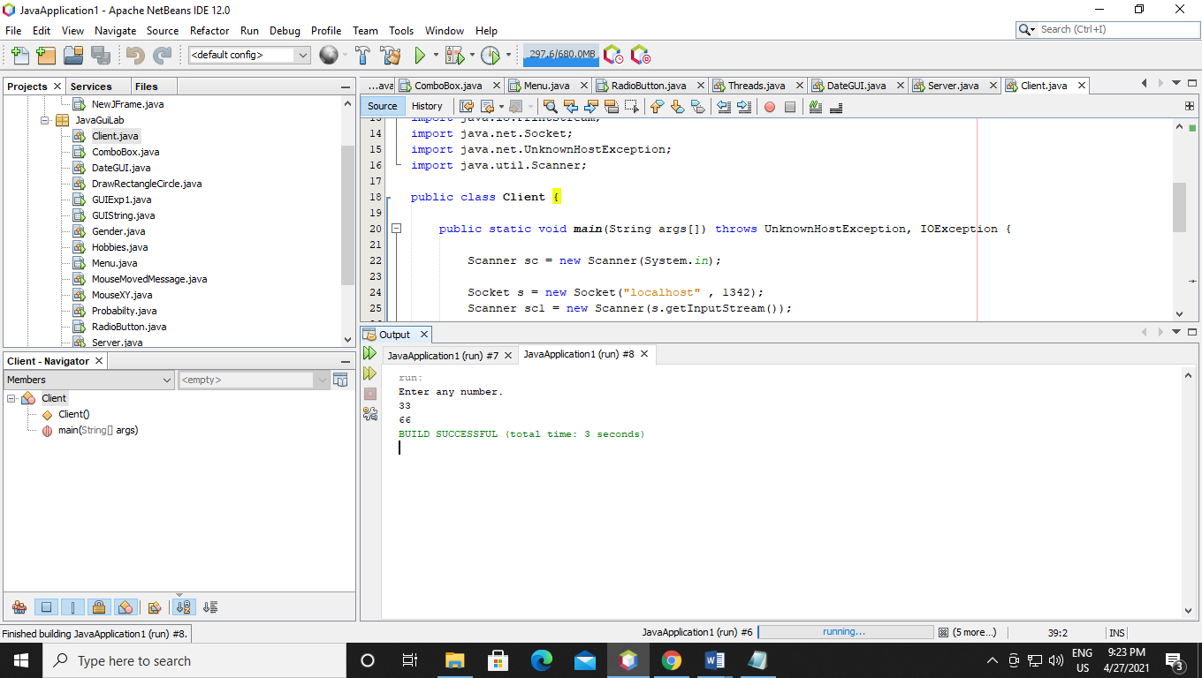

Q27 Write java program to create vector gui

Code:-

package JavaGuiLab;

/**

*

* @author prathmesha

*/

import java.awt.BorderLayout;

import java.awt.FlowLayout;

import javax.swing.JButton;

import javax.swing.JDialog;

import javax.swing.JPanel;

import javax.swing.border.EmptyBorder;

import java.awt.event.ActionListener;

import java.util.Stack;

import java.util.Vector;

import java.awt.event.ActionEvent;

public class JavaVector extends JDialog {

private final JPanel contentPanel = new JPanel();

/**

* Launch the application.

*/

public static void main(String[] args) {

try {

JavaVector dialog = new JavaVector();

dialog.setDefaultCloseOperation(JDialog.DISPOSE_ON_CLOSE);

dialog.setVisible(true);

} catch (Exception e) {

e.printStackTrace();

}

}

/**

* Create the dialog.

*/

public JavaVector() {

setBounds(100, 100, 450, 300);

getContentPane().setLayout(new BorderLayout());

contentPanel.setBorder(new EmptyBorder(5, 5, 5, 5));

getContentPane().add(contentPanel, BorderLayout.CENTER);

contentPanel.setLayout(null);

JButton btnNewButton = new JButton("Vector Element");

btnNewButton.addActionListener(new ActionListener() {

public void actionPerformed(ActionEvent e) {

Vector v = new Vector();

int cap = v.capacity();

System.out.println("The initial capacity of a vector " + cap);

v.addElement("Prathmesh");

v.addElement("GROOT");

v.addElement("Monu");

v.addElement("Joker");

v.addElement("Tom");

int sizeV = v.size();

System.out.println("The initial Size of a vector " + sizeV);

System.out.println("Vector Element are: ");

System.out.println(v);

}

});

btnNewButton.setBounds(112, 36, 134, 27);

contentPanel.add(btnNewButton);

{

JButton btnNewButton_1 = new JButton("STACK");

btnNewButton_1.addActionListener(new ActionListener() {

public void actionPerformed(ActionEvent e) {

Stack s = new Stack();

int cap = s.capacity();

System.out.println("Initial capacity is " + cap);

s.push("PQ");

s.push("RS");

s.push("TU");

s.push("VW");

s.push("XY");

int size = s.size();

System.out.println("initial size is " + size);

System.out.println(s);

System.out.println("First Element is " + s.get(1));

System.out.println("Second element is " + s.get(2));

s.pop();

System.out.println("after pop is");

System.out.println(s);

}

});

btnNewButton_1.setBounds(112, 93, 134, 27);

contentPanel.add(btnNewButton_1);

}

{

JPanel buttonPane = new JPanel();

buttonPane.setLayout(new FlowLayout(FlowLayout.RIGHT));

getContentPane().add(buttonPane, BorderLayout.SOUTH);

{

JButton okButton = new JButton("OK");

okButton.setActionCommand("OK");

buttonPane.add(okButton);

getRootPane().setDefaultButton(okButton);

}

{

JButton cancelButton = new JButton("Cancel");

cancelButton.setActionCommand("Cancel");

buttonPane.add(cancelButton);

}

}

}

}

Output:-

Vector:-

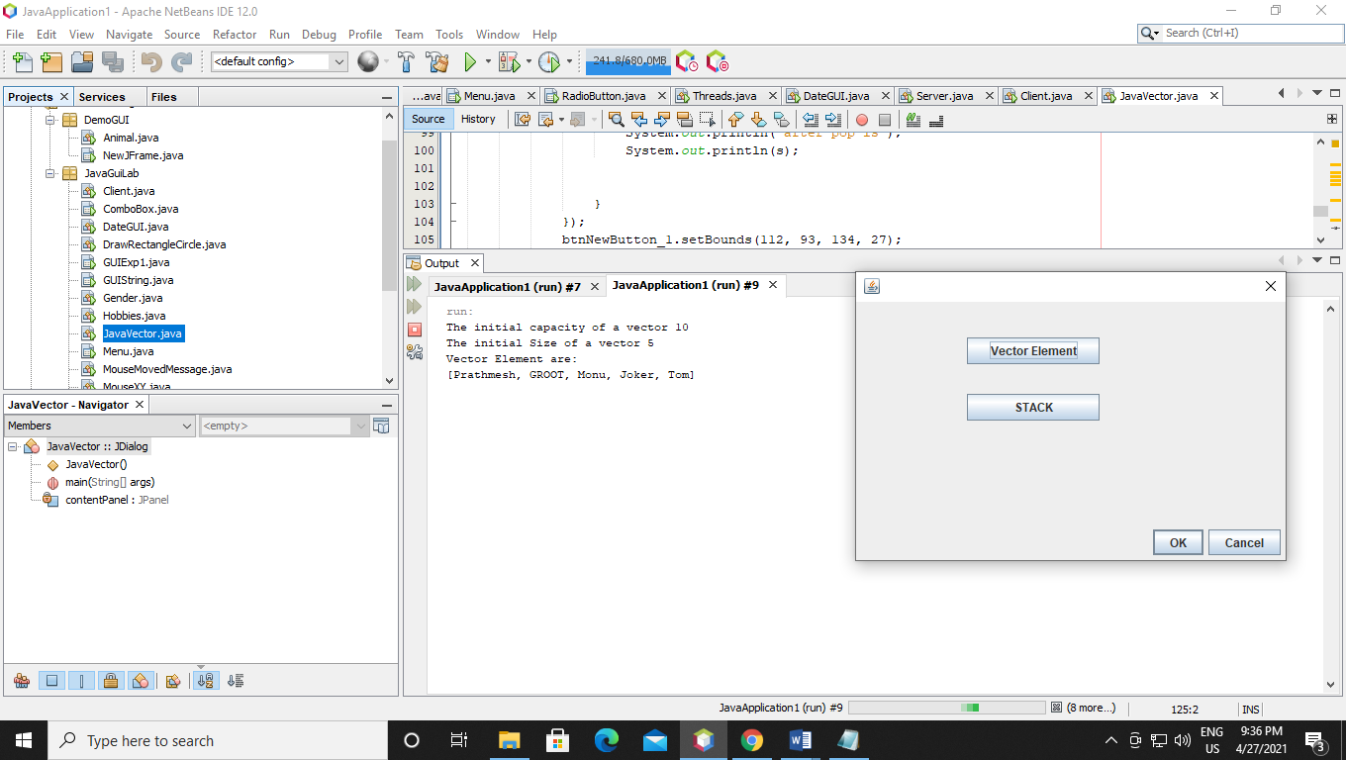

Stack:-

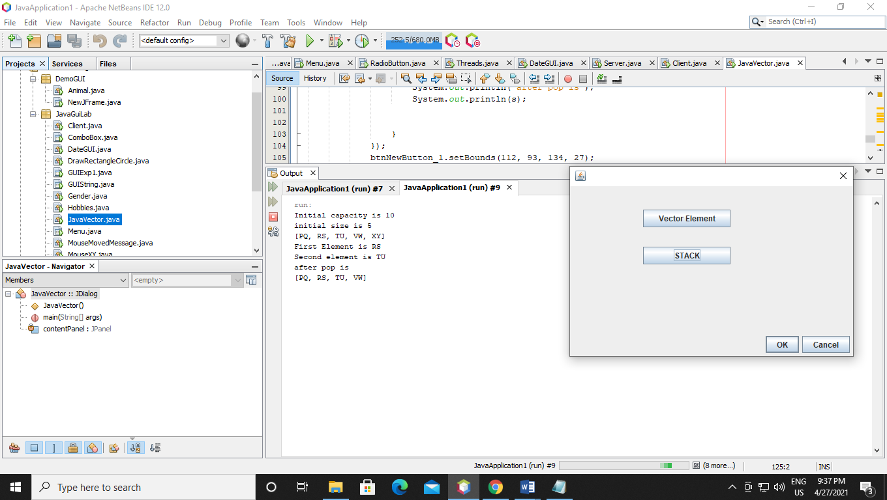

Q28 Write java program to create server and client connection by sending message

Code:-

Server:-

package JavaGuiLab;

/**

*

* @author prathmesha

*/

import java.awt.BorderLayout;

import java.awt.EventQueue;

import javax.swing.JFrame;

import javax.swing.JPanel;

import javax.swing.border.EmptyBorder;

import javax.swing.JButton;

import java.awt.event.ActionListener;

import java.io.DataInputStream;

import java.io.IOException;

import java.net.ServerSocket;

import java.net.Socket;

import java.awt.event.ActionEvent;

public class ServerMsg extends JFrame {

private JPanel contentPane;

/**

* Launch the application.

*/

public static void main(String[] args) {

EventQueue.invokeLater(new Runnable() {

public void run() {

try {

ServerMsg frame = new ServerMsg();

frame.setVisible(true);

} catch (Exception e) {

e.printStackTrace();

}

}

});

}

/**

* Create the frame.

*/

public ServerMsg() {

setDefaultCloseOperation(JFrame.EXIT_ON_CLOSE);

setBounds(100, 100, 513, 396);

contentPane = new JPanel();

contentPane.setBorder(new EmptyBorder(5, 5, 5, 5));

setContentPane(contentPane);

contentPane.setLayout(null);

JButton btnNewButton = new JButton("SERVER");

btnNewButton.addActionListener(new ActionListener() {

public void actionPerformed(ActionEvent e) {

ServerSocket ss = null;

try {

ss = new ServerSocket(6666);

} catch (IOException e1) {

e1.printStackTrace();

}

System.out.println("Server is waiting..");

Socket s = null;

try {

s = ss.accept();

} catch (IOException e1) {

// TODO Auto-generated catch block

e1.printStackTrace();

}//establishes connection

DataInputStream dis = null;

try {

dis = new DataInputStream(s.getInputStream());

} catch (IOException e1) {

// TODO Auto-generated catch block

e1.printStackTrace();

}

String str = null;

try {

str = (String)dis.readUTF();

} catch (IOException e1) {

// TODO Auto-generated catch block

e1.printStackTrace();

}

System.out.println("message= "+str);

try {

ss.close();

} catch (IOException e1) {

// TODO Auto-generated catch block

e1.printStackTrace();

}

}

});

btnNewButton.setBounds(179, 123, 155, 55);

contentPane.add(btnNewButton);

}

}

Client:-

package JavaGuiLab;

/**

*

* @author prathmesha

*/

import java.awt.BorderLayout;

import java.awt.EventQueue;

import javax.swing.JFrame;

import javax.swing.JPanel;

import javax.swing.border.EmptyBorder;

import javax.swing.JButton;

import java.awt.event.ActionListener;

import java.io.DataOutputStream;

import java.io.IOException;

import java.net.Socket;

import java.net.UnknownHostException;

import java.awt.event.ActionEvent;

public class ClientMsg extends JFrame {

private JPanel contentPane;

/**

* Launch the application.

*/

public static void main(String[] args) {

EventQueue.invokeLater(new Runnable() {

public void run() {

try {

ClientMsg frame = new ClientMsg();

frame.setVisible(true);

} catch (Exception e) {

e.printStackTrace();

}

}

});

}

/**

* Create the frame.

*/

public ClientMsg() {

setDefaultCloseOperation(JFrame.EXIT_ON_CLOSE);

setBounds(100, 100, 515, 412);

contentPane = new JPanel();

contentPane.setBorder(new EmptyBorder(5, 5, 5, 5));

setContentPane(contentPane);

contentPane.setLayout(null);

JButton btnNewButton = new JButton("CLIENT");

btnNewButton.addActionListener(new ActionListener() {

public void actionPerformed(ActionEvent e) {

Socket s = null;

try {

s = new Socket("localhost",6666);

} catch (UnknownHostException e1) {

e1.printStackTrace();

} catch (IOException e1) {

e1.printStackTrace();

}

DataOutputStream dout = null;

try {

dout = new DataOutputStream(s.getOutputStream());

} catch (IOException e1) {

e1.printStackTrace();

}

try {

dout.writeUTF("Hello Server");

} catch (IOException e1) {

e1.printStackTrace();

}

try {

dout.flush();

} catch (IOException e1) {

e1.printStackTrace();

}

try {

dout.close();

} catch (IOException e1) {

e1.printStackTrace();

}

try {

s.close();

} catch (IOException e1) {

e1.printStackTrace();

}

}

});

btnNewButton.setBounds(158, 140, 142, 55);

contentPane.add(btnNewButton);

}

}

Output:-

Server display:-

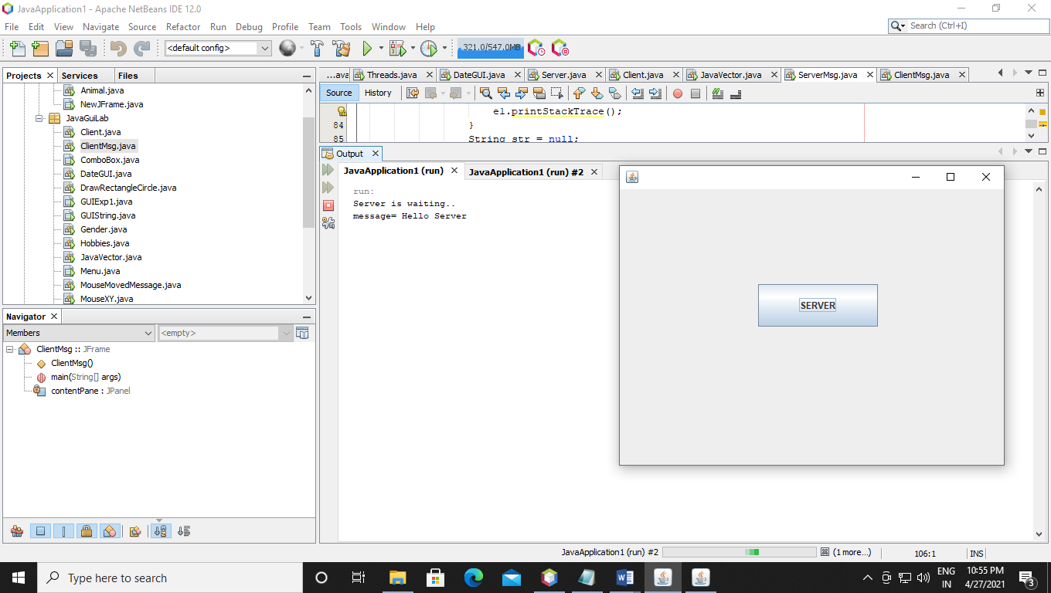

Client Display:-

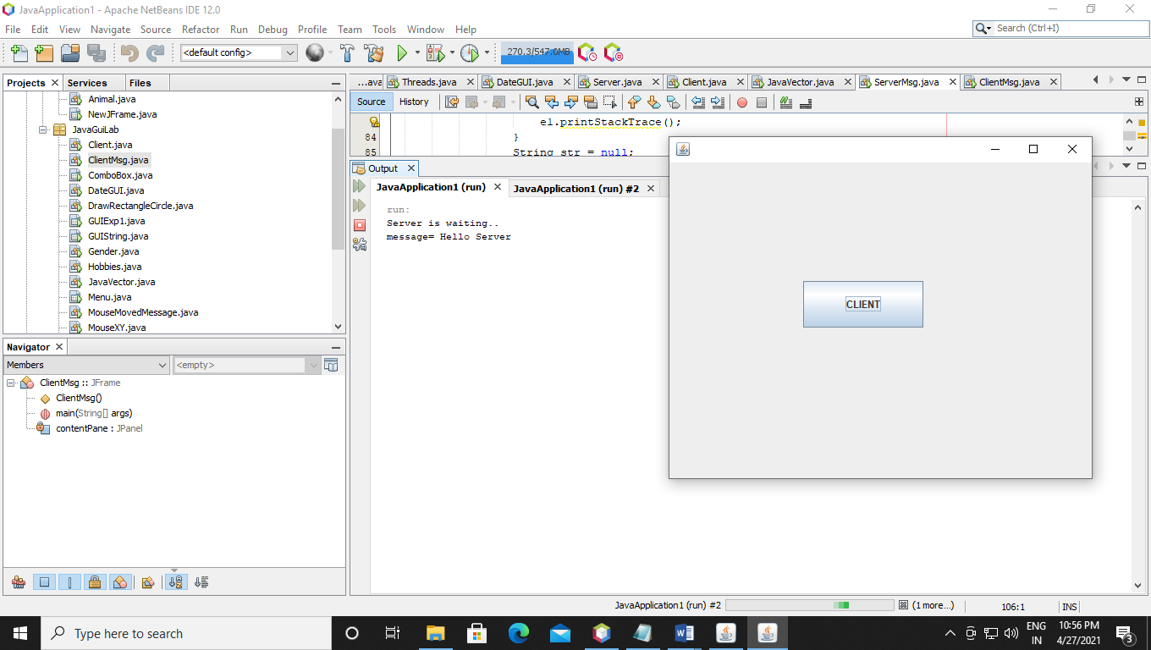

Q39 Write java program to access database connection and view table

Code:-

package JavaGuiLab;

/**

*

* @author prathmesha

*/

import java.awt.BorderLayout;

import java.awt.EventQueue;

import javax.swing.JFrame;

import javax.swing.JPanel;

import javax.swing.border.EmptyBorder;

import java.sql.*;

import javax.swing.JTextField;

import javax.swing.JButton;

import java.awt.event.ActionListener;

import java.awt.event.ActionEvent;

import javax.swing.JTable;

import javax.swing.border.LineBorder;

import java.awt.Color;

public class DBTable extends JFrame {

private JPanel contentPane;

static String sql;

static Connection conn;

static Statement statement;

public static ResultSet rs;

private JTextField textField;

private JTextField textField_1;

private JTextField textField_2;

private JTable table;

/**

* Launch the application.

*/

public static void main(String[] args) {

EventQueue.invokeLater(new Runnable() {

public void run() {

try {

DBTable frame = new DBTable();

frame.setVisible(true);

frame.setTitle("MS-Access Database Connectivity");

} catch (Exception e) {

e.printStackTrace();

}

}

});

try {

conn=DriverManager.getConnection("jdbc:ucanaccess://D:/Prathmesh/JAVA/Database/Student.accdb");

} catch (SQLException e) {

e.printStackTrace();

}

sql = "SELECT * FROM BCA";

try {

statement = conn.createStatement();

} catch (SQLException e) {

e.printStackTrace();

}

try {

rs = statement.executeQuery(sql);

/*

while(rs.next()){

System.out.println(rs.getString(1));

System.out.println(rs.getString(2));

System.out.println(rs.getString(3));

}

*/

} catch (SQLException e) {

e.printStackTrace();

}

}

/**

* Create the frame.

*/

public DBTable() {

setDefaultCloseOperation(JFrame.EXIT_ON_CLOSE);

setBounds(100, 100, 689, 374);

contentPane = new JPanel();

contentPane.setBorder(new EmptyBorder(5, 5, 5, 5));

setContentPane(contentPane);

contentPane.setLayout(null);

textField = new JTextField();

textField.setBounds(23, 49, 151, 36);

contentPane.add(textField);

textField.setColumns(10);

textField_1 = new JTextField();

textField_1.setBounds(234, 49, 151, 36);

contentPane.add(textField_1);

textField_1.setColumns(10);

textField_2 = new JTextField();

textField_2.setBounds(467, 49, 151, 36);

contentPane.add(textField_2);

textField_2.setColumns(10);

JButton btnNewButton = new JButton("Next Record");

btnNewButton.addActionListener(new ActionListener() {

public void actionPerformed(ActionEvent e) {

try {

if(rs.next())

{

textField.setText(rs.getString(1));

textField_1.setText(rs.getString(2));

textField_2.setText(rs.getString(3));

}

else

{

rs.close();

rs = statement.executeQuery(sql);

}

} catch (SQLException e1) {

// TODO Auto-generated catch block

e1.printStackTrace();

}

}

});

btnNewButton.setBounds(36, 131, 112, 30);

contentPane.add(btnNewButton);

JButton btnNewButton_1 = new JButton("Add");

btnNewButton_1.addActionListener(new ActionListener() {

public void actionPerformed(ActionEvent e) {

PreparedStatement preparedStatement;

try {

preparedStatement = conn.prepareStatement("insert into BCA values(?,?,?)");

String s1=textField.getText();

String s2=textField_1.getText();

String s3=textField_2.getText();

preparedStatement.setString(1, s1);

preparedStatement.setString(2, s2);

preparedStatement.setString(3, s3);

preparedStatement.executeUpdate();

System.out.println("data inserted successfully");

} catch (SQLException e1) {

e1.printStackTrace();

}

}

});

btnNewButton_1.setBounds(36, 191, 112, 30);

contentPane.add(btnNewButton_1);

table = new JTable();

table.setBackground(Color.DARK_GRAY);

table.setBorder(new LineBorder(new Color(0, 0, 0), 2));

table.setBounds(270, 131, 250, 175);

contentPane.add(table);

}

}

Output:-

